DOCTORS NEAR ME (APPOINTIFY)

A Project Report

Submitted in partial fulfillment of

the requirements for the award of the Degree of

##### BACHELOR OF SCIENCE (INFORMATION TECHNOLOGY)

By

Shraddha Parab (35)

Apurva Satam (51)

**Under the esteemed guidance of**

**Prof. Swati Deore**

##### Department of Information Technology



**DEPARTMENT OF INFORMATION TECHNOLOGY**

##### TOLANI COLLEGE OF COMMERCE

***(Affiliated to University of Mumbai)***

**MUMBAI, 400 093 MAHARASHTRA 2019 – 2020**

##### TOLANI COLLEGE OF COMMERCE

***(Affiliated to University of Mumbai)***

**MUMBAI-MAHARASHTRA-400093**

##### DEPARTMENT OF INFORMATION TECHNOLOGY



**CERTIFICATE**

This is to certify that the project entitled, "**____________________**”, is bonafied work of **____________** bearing roll no: **35** submitted in partial fulfillment of the requirements for the award of degree of BACHELOR OF SCIENCE in INFORMATIONTECHNOLOGY from University of Mumbai.

Internal Guide Coordinator

**External Examiner**

**Date: College Seal**

# ABSTRACT

The “DOCTOR NEAR ME” system has been developed to override the problems prevailing in the practicing manual system. This app supports to eliminate and, in some cases, reduce the hardships face by this existing system.

Moreover, this system is designed for the particular need of the user or patient to carry out operation in a smooth and effective manner. The Online Medical Booking System is very easy to use, full-featured and flexible appointment management portal. It allows patient to view list of doctor’s available appointment time.

Administrator can manage doctor’s database and schedule from web-based control panel.

Doctors can view their appointment list from the portal. The purpose of doctor near me system is to automate the existing manual system by the help of computerized equipment’s and full- fledged computer software, fulfilling their valuable data/information can be stored for a longer period with easy accessing and manipulation of the same.

Doctor near me System, as described above, can lead to error free, secure, reliable and fast management system. It can assist the user to concentrate on their other activities rather to concentrate on the record keeping. This app is useful for people who face the problem personally, and is also helpful in knowing information about doctor information & blood shortage.

# ACKNOWLEDGEMENT

It takes great pleasure to me to present project report on **“Project Name”**.

I would like express my deepest thanks and gratitude to my project guide, **Prof.** project guide name , for her guidance and help during each step of the project.

I would like to express my thanks and gratitude to my parents and their utmost support during the academic year so that I can focus properly on my project. With proper coordination and full fledge cooperation among me and my guide, I was able to complete this project successfully.

I would also like to express gratitude and thanks to Co-Ordinator **Prof. Bandita Singh** and all the teaching staff of I.T Department for their utmost help and support in the project. Finally, I wish to express profound thanks to all those who helped me in any way regarding the project.

Student Name

# DECLARATION

I hereby declare that the project entitled, “**____________”**, done at Tolani College of Commerce, has not been in any case duplicated to submit to any other universities for the award of any degree. To the best of my knowledge other than me, no one has submitted to any other university.

The project is done in partial fulfillment of the requirements for the award of degree of **BACHELOR OF SCIENCE (INFORMATION TECHNOLOGY)** to be submitted as final semester project as part of our curriculum.

Signature of Students (_______________)

|  |  |  |
| --- | --- | --- |
| **SR.NO** | **TITLE** | **PAGE.NO** |
| **1** | **INTRODUCTION**   * 1. Introduction   2. Background   3. Objective   4. Purpose, Scope and Applicability   5. Achievements |  |
| **2** | **SURVEY OF TECHNOLOGIES** |  |
| **3** | **SYSTEM ANALYSIS**   * 1. Problem Definition   2. Modular Description |  |
| **4** | **REQUIREMENT ANALYSIS**   * 1. Functional Requirement   2. Software and Hardware Requirement |  |
| **5** | **SYSTEM DESIGN**   * 1. Class Diagram   2. Sequence Diagram   3. Use Case Diagram   4. Activity Diagram   5. ER Diagram   6. Data Design   7. Data Integrity and Constraints |  |
| **6** | **PLANNING AND SCHEDULING**  **GANTT CHART** |  |
| **7** | **CONCLUSION** |  |
| **8** | **REFERENCES** |  |

**TABLE OF CONTENTS**

**INTRODUCTION**

##### Introduction:-

With Doctor near me your patient can book their preferred doctor’s appointment online, at their own convenience, any time of the day, any day of the week.

The Online Doctor near me System is easy to use, full-featured and flexible appointment management portal. It allow patient to view all list of doctors, available appointment time.

Administrator can manage doctors database and schedule from web based control panel. Doctor can view their appointment list from this portal.

The “Doctor near me” System has developed to override the problems prevailing in the practicing manual system. This app is supported to eliminate and in some case reduce the hardships faced by this existing system. Moreover this system is designed for the particular need of the patient to carry out the operation in a smooth and effective manner.

The application is reduced as much as possible to avoid errors while entering the data. It also provides errors message while entering wrong data.

This app’s is helpful for people who face the problem personally in day to day life, and is also helpful in knowing information about doctor info.

##### Background:-

With “Practo” patients can book their preferred doctor’s appointment online, at their own convenience, any time of the day, any day of week. That’s right, the Practo online booking system is available to patients 24/7.

When your patients make an online doctor’s appointment with Practo, they receive email and mobile notification to help remind them and reduce your number of ‘no-shows’.

Over the past five years since Practo went live, this has already shown to increase the number of patients who return within twelve months by 35% online bookings are currently doubling each year and 78% of existing patients recommend Practo to their friends.

Practo search engine optimisation (SEO) technology wills also left a practice’s ranking on Google making their practice more visible to potential looking for quick, convenient online information and bookings. As part of the Practo network team ensure they’re constantly working to improve their practice’s search ranking.

The Doctor near Me system is easy to use, full-featured and flexible appointment Management portal. It allow patient to view list of doctors, available appointment time, cancel appointment, view his appointment history. Administrator can manage doctors database and schedule from web based control panel. Doctors can view their appointment list from this portal.

This App is useful for people who face the problem personally, and is also helpful in knowing information about Medical Sciences.

##### Objective:-

The main objective of the project on Doctor near Me System is to manage the details of Doctor, Appointment, Patient, Booking, and Blood. It manages all the information about Doctor, blood information. The project is totally built at administrator is guaranteed the access.

This App is useful for people who face the problem personally, and is also helpful in knowing information about Doctor near & doctor info area wise or category wise.

##### Purpose, Scope and Applicability:-

* + 1. Purpose:-

The purpose of the project is to build an application program to reduce the manual work for managing the Doctor, Appointment, and Doctor & blood information. It tracks all the details about the Patients, Booking.

This App is useful for people who face the problem personally, and is also helpful in knowing information about nearest doctor by category wise or area wise.

My system will take a stand and will be a platform at which people can find doctor, see their qualification, expertise and book appointment. There is no need to visit the doctor’s hospital they can do so with this application.

The application is supported to eliminate and in some cases reduce the hardship faced by the existing system. Doctor near me system, as described above, can lead to error free, and secure, reliable and fast management system.

* + 1. Scope:-

My application should also help the patient for collecting perfect management in details. In a very short time, the information will be obvious, easy and sensible. My application also helps in current all works relative to Doctor Management system. With this application people will not only save effort but time too.

* + - * It satisfies the user requirements.
      * It’s very easy to understand by the user and operator
      * Be expandable
      * Save effort as well as time
      * Have a good user interface
      * The online scheduler which contain all doctors available time of management
      * The system generates types of information that can be used for various purpose

##### Applicability:-

* + - * This application has a wide range of options where it can enhance the requirements.
      * It makes the easy availability and less time consuming process of doctor’s appointments.
      * This application has various procedures and options so that the user does not feel that the application lacks elsewhere
      * The application will be user friendly and will make a good impact on the doctors and patients.

##### Achievements:-

* This application has provided us with much information regarding the resources which will be used in the development of the project.
* Android Studio has been the most compatible software for developing android applications. It is more user friendly as compared to others.
* There are various possibilities where the doctors lack the patient’s communication due to which many casualties may occur.
* This application will minimize as much casualties as possible to reduce issues of the patients and doctors simultaneously.
* This application will focus on various types of doctors so as to make it easy for the user to use the application.

# SURVEY OF TECHNOLOGIES

Survey on Tools and Technologies Applicable For Mobile Application Development

***Abstract:-***

In the today’s day to day life fast and studious world of fashionable phones, everyone wants to become smart by saving their time and money. With estimate to this, the developers are always strong about providing the elegant ways and approaches through the Android Mobile App for the familiar users so that they can have smart lifestyle. To provide the smart Android Apps which works on smart devices, the variety is there in the running of tools and technologies. Some of the tools and technologies are specifically designed and developed to work for Android Phones, since most of the users are using Android phones.

Hence it is a currently revolt technology which is growing fast in today’s market. In this survey paper, we have provided the details about the Mobile Application development Environment and its usages along with Android Technology and their tools, and also use of MySQL open source database technology.

###### Introduction:-

In today’s technological world everybody is looking for the on-hand smart and perfect technological solution to satisfy their day to day requirements. So most of the experts have right now looking forward to provide such types of the smart apps which will be used through their smart phones. Different types of apps are designed and developed to satisfy the day to day life requirements such as paying online payment of the light bills, online purchasing through the Flip kart app, to listen music using Saaremaa App , or to perform banking transactions, the different Banking Apps are available.

The apps are available for entertainment, education, shopping, etc. To design and develop the Mobile Apps, there is necessity to make a survey of the tools and technologies used and which are popular in the world of mobile apps developers.

This survey paper is giving the concentration on the different tools and technologies used for designing and developing mobile apps. The sequence of survey is distributed throughout the paper to provide the survey of the tools and technologies used for Mobile Application development.

**The section 1:** gives the introduction of the survey made in the context of the Mobile Application Development.

**The section 2:** specifies the specific tools used to develop the smart apps and detail comparison with regards to their uses.

**The section 3:** gives the survey of the Android Technologies and MySQL used to develop the mobile app.

***Tools Used To Develop Mobile App:-***

**Introduction of Mobile App: -**

Application software designed and developed to run on mobile device such as Smartphone’s or Tablets are called as an app. This process is also called as Mobile Application Development which is similar to the Web Application Development process whose roots are in the process of traditional software development.

Mobile applications provide all required services as like of the application software’s developed for Pcs such as online shopping, performing online banking applications, etc. There is slight difference between the application software’s and the apps are the small software programs which are developed to meet the intended specific requirement of the users.

These apps are also called as smart phone apps or Android apps or iPhone apps since these are developed to take advantages of unique features of particular mobile such as Android Mobiles, iPhone mobiles or Microsoft Mobiles. Michael Face mire, an app developer for Forrester Research has a statement on app as “Mobile app dev tools are like paint brushes for an artist – they all come down to personal preference. Personally, I use some of the most well-known, like Android Studio, because they help me develop apps quickly.

###### Tools Information:-

The different tools are used to first of design the Mobile App which are:

**Android Studio** – This is IDE created by community named “IntelliJIDEA“used as plat form for developing Mobile Apps based on Android Technology. The IntelliJIDEA, Android based studio provides massive amount of plug-in created by different communities.

**Eclipse** – This IDE is used to develop the programs in Java and it also enables the developer to expand with other languages via plug-in.

**Droid Edit** – This is a text and code editor used on Android platforms for writing the programs.

**Android-IDE** – A complete web and Android development environment that allows writing and editing Java and Phone Gap apps.

**Android Language Resources-** The variety of languages is used to develop Android applications but the heart of Android development is the Java programming language. The C and C++ programming languages can also be used but it can be resulted into increase in complexity. These languages can be used with the Android Native Development Kit to create Android apps.

**Android Libraries**- In the scenario of software development, a library is a collection of the data which can do different things such as:

1. **Universal Image Loader** – This is used to load and catch the images and it is highly customizable.
2. **GSon** – This is used for serializing and desterilizing Java objects in JSON.
3. **Retrofit** – This is used as a “elegant solution for organizing API calls”.
4. **Awesome Java** – It contains some of the best Java frameworks and libraries.
5. **Android View Animations** – This is a library which provides way to get regular View Animations.

**Android Plug**- INS- Android plug-in is used to provide the extra features, which are not included in used application development platform.

###### Technologies Used To Design and Develop Smart App:-

**Android**:-

Android is based on the Linux kernel and the source code is available under the Apache license (so it's free to use and modify) for anyone to download. Android Is More Customizable Can changes almost anything.

##### Advantages and Limitations of Android Technology:-

**Advantages of Android:-**

* 1. Android Google Developer

The biggest advantage of the Android is Google. Android operating system is owned by Google. Google is one of the most trusted and reputed product on the internet. The name Google provides lots of trust for the users to buy Android device.

* 1. **Android Users** – Billion of USERS

Android is the most used mobile operating system. It is used by over billion people. Android is also the fastest growing operating system on the earth. Android has billions of users. A number of users increase the number of applications and software under the name of Android.

* 1. Android Multitasking-

Most of us love this feature of the android. Users can do lots of tasks at once. Users can open several applications at once and manage them all too. Android has great UI which makes easy for users to do multitasking.

* 1. **Android Notification** – Easy Access

One can easily get access to their notification of any kind of SMS, emails or calls on their home screen or the notification panel of the android phone.

##### Limitations of Android:-

1. **Little Memory for Storage**-the Android technology does not provide large amount of memory so the developer need to provide the approach for storing the data of the intended user of the app.
2. **Force Close on Large App/Games**: Due to the small amount of RAM available on Android phones, some applications put up huge loads on processor and because of this smart phone get hanged. To avoid the hanging of the phone, the application needs to be forcefully stopped at any condition.
3. **Data Connection**- Android has large number of background process which runs in the background, which eats so much mobile data. And thus cost lots of money if you are not into unlimited data plan. 4. Battery Problem- While android has many processes running in the background this increase the usage of RAM and decreasing Battery Performance. While many top notch device has good battery backup (Lithium Batteries) but still that doesn’t mean it solved the problem.
4. **Security-** Android technology does not provide in built security, it is all up to the developer to take care of providing the security while developing the App.

###### MySQL:-

For developing the web applications as well as business applications, there is need to store the data and for this purpose most of the experts prefer the open source database applications which are also applicable while developing the mobile app. Therefore, this facility of the open source database has been provided by MySQL. MySQL is a fast, easy-to-use RDBMS which is used for storing data generated through the small applications and big business applications. MySQL is developed, and supported by MySQL AB, and it is popular because of following reasons:

1. MySQL is an open-source license so user has nothing to pay to use it. It handles large databases, so it will possible to organize 50 million rows or more in a table with default file size limit for a table is 4GB.
2. MySQL handles a large subset of the functionality of the most expensive and powerful database packages. 3. MySQL uses a standard form SQL data language.
3. MySQL works on many operating systems and with many languages including PHP, PERL, C, C++, JAVA, etc.

###### Justification of selection of Technology:-

* 1. Android can be easily accessed

According to reliable recent statistics by idc.com, Google’s Android gobbled up market share to a large extent, accounting for 80% of all smart phones shipped globally. The best part of Android is that it is easily accessible to any Android programmer with knowledge of Java and the Android SDK. The Android SDK can be easily accessed and has the potential and capability to create some of the most innovative mobile apps.

* 1. Innovative and creative

Because of the open source nature of Android, the developers who get to work on this mobile platform get a lot of exposure to Google’s philosophy of freedom and innovation. This encourages creativity and nurtures the ability to take advantage of Android’s vast resources that improve the quality and functionality of your mobile app.

* 1. Ability to install from any source

Android apps can be installed from any source and not just the Android Market. Besides it is easy and possible to test the apps on multiple devices. All this is possible due to the tools included in the SDK that make it easy to do so. It is also possible to directly install your app on the device directly, or from the command line.

* 1. Much lower entry barrier

If you want to develop your app in Android, you only need to register yourself as a developer on the Android market, prepare your APK and submit it to Android. The entry barrier for Android is much lower as the approval process is much simpler, which is not the case with its nearest competitor App Store.

* 1. High market share

The fact that Android’s market share accounts to over 80% with over 1 billion devices being shipped in 2014 alone, means a lot to those investing their pennies in the Android development game. This means that building an android app will mean a lot of potential downloads, which is actually a good sign for the developer community.

* 1. Allows installation of custom ROMs

Android allows rooting of your phone and you can install custom ROMs. On the contrary, phone’s version of rooting is called jail breaking, which is an actual crime in the USA.

* 1. Better hardware range

Android is made to be more compatible with devices that are provided by different manufacturers around the globe. These developers include a wide range of advanced features into the device, which can then be effectively utilized by developers worldwide.

These features are comparable to those available with the expensive models and high-end phones, and are also easy to fit into your budget.

* 1. Well optimized for social apps

Android is well optimized to develop social apps and this segment is really growing. Most apps developers are going social, and are trying their best to maximize their potential by earning top revenue. Hence, due to its ability to better integrate with a wide range of social networks, it is more preferred amongst developers and business owners who want to go social.

* 1. Easier to learn

According to various professionals who have learnt Google Android and other

platforms such as iOS and Blackberry, Google’s Android can be learnt from scratch, faster than other platforms. Hence, developers starting out with mobile application development will find it very easy to develop in Android.

* 1. Cheaper Apps

Android has a diverse user-base, hence offers more free downloads. Also, apps are cheaper compared to those on iOS, and free apps with ad revenue or in-apps purchase models are also possible on Android.

###### Conclusion:-

The conventional software development scenario is changing with the usages of the smart devices such as Mobile phone or tablets. This results in opening of a door for development of applications which will work on Smart Devices in the smarter way, called as the “Mobile Apps”.

With respect to development of the mobile app, the above survey is made.

This concludes that, the developer can make the use freely available, open source tools and technologies which are user friendly.

# SYSTEM ANALYSIS

##### Problem Definition:- Spotting error message

There’s a wide range of error messages you may encounter when testing your app, ranging from severe errors that will cause your app to crash the very first time you try to install it on a target device to more subtle errors that degrade your application’s performance over time. Depending on the kind of error you encounter, Android will display the error message either on the device you’re using to test your app or in Android Studio.

* + 1. Please Choose a Valid JDK Directory:-

If you’re getting a JDK error whenever you try to build your app, then it means Android Studio is struggling to find where the JDK is installed on your development machine.

* + 1. Error Installing APK:-

While AVDs are great for testing your app across a wide range of different hardware and software, you should always test your app on at least one physical Android Smartphone or tablet. However, Android Studio’s ability to recognize a connected Android device is notoriously hit and misses.

* + 1. Install_Failed_Insufficent_Storage:-

If you encounter this error when attempting to install your project, then it means the target device doesn’t have enough memory.

* + - * **RAM.** The amount of RAM available to the emulated device.
      * **Internal Storage.** The amount of non-removable memory available to the emulated device.
      * **SD card.** The amount of removable memory available. If you want to use a virtual SD card that’s managed by Android Studio, then select Studiomanaged and enter the size of the virtual SD card you want to create.
    1. ActivityNotFoundException:-

This exception is thrown when a call to start Activity fails because the Activity cannot be found. Usually, this means you forgot to declare the Activity in your Manifest.

* + 1. NullPointerException:-

A NullPointerException occurs when you use a reference that points to ‘no location’ in memory (null) as though you’re referencing an object. For example, maybe you’re trying to call the instance method of a null object, or modifying the slots of null as though it’s an array.

##### The existing system has the fallowing requirement:

* System needs store information about new entry of Doctor.
* System needs to help the internal staff to keep information of Appointment and find them as per various queries.
* System need to maintain quantity record.
* System need to keep the record of Patient.
* System need to update and delete the record.
* System also needs s a search area.
* It also needs a security system to prevent data.

##### *Modular Description:

* **Login Info Module:** A Login, logging in or logging on is the entering of identifier information into a system by answer in order to access to that system.
* **Doctor Module:** Redirect you to admin page/module or user module. As per login info.
* **Appointment Module:** The process of booking of appointment is done through module**.**
* **User Module:** User is the one that performs the action of booking, searching. Searching for appropriate Doctor or Blood firstly have category and secondly by area.
* **Admin Module:** The admin works as the steering the android application as he is the one who add the Doctor based on the criteria of categories and area. The qualification of doctor is verified & added to the app by the admin. If the doctor wishes to update any of his details he has to intimate the admin. The admin has the rights to insert, update and delete any operation from the application.
* **Blood module:** The feature of blood donating and receiving is carried out through this module. Here in doctor enters his information which is then fetched when needed. A needy can get blood directly from the location where he is, can search blood by area wise.

# REQUIREMENTS ANALYSIS

The system is required to accomplish the following:-

1. Access Control

Only authorized users must be allowed to access the system.

1. Updation

Updating of notice must be real time and easy for user to operate.

1. User friendly

The system must be simple to use so that anyone can operate it.

1. Network Connectivity

Internet connectivity is required for doctor near me system.

1. Google Maps

Google Maps is also required in our system.

1. Android Device

Our System is work on only android devices.

**REQUIREMENT SPECIFICATION:**

* Provides the near searching facilities based on various such as Doctor and Blood.
* it tracks all the information of users and their preferences.

##### Functional Requirement: Authentication

* + - **Login-** The user can login to the authentication system username and password.
    - **Logout-** The user can log out from the apps after complete their work.
    - **Login failure-** If the user does not match in the login phase or the user has not yet being authorized by the admin.

##### Non-Functional Requirement:

*1.* Performance Requirement

*Performance requirements define the acceptable response times for system functions: -*

1. The system shall take initial load time depending on the internet connection strength which also depends on the media from which the application is running.
2. The performance shall depend on the hardware components of the client.
3. The Blood Donation website must be accessible and up and running 24 hours a day, 7

days a week and 365 days a year.

1. The project shall display clear human-readable error messages.
2. Maintainability Requirement

It should be easy to add, remove or modify modules in this website. Debugging should not be difficult.

1. Availability Requirement

The website should be available 24 x 7. Services should be provided to the customers as and when requested.

##### Software and Hardware Requirement:-

* + 1. **Hardware Requirement:-**

|  |  |
| --- | --- |
| **For development In System:** |  |
| RAM | Minimum 4 GB |
| Processor | Core2Duo Or Above |
| Space Required | 20 GB HD Space Minimum |
| **For development In Mobile:** |  |
| Version | Android 5.0 Or Above |

##### 1.2 Hardware Requirement table:

* + 1. **Software Requirement:-**

|  |  |
| --- | --- |
| **For development of Application in Systems:** |  |
| Operating System | Windows 7 or Above, Android Studio |
| Front-End Language | JAVA-Primary android development language. |
| Back-End Database | SQLite |
| **For Applications in Mobile:** |  |
| Version | Android Kitkat Or Above |

* 1. **Software Requirement table:**

**Preliminary Product Description:-**

The first step in the system development life cycle is the preliminary description to determine the feasibility of the system. The purpose of the preliminary description is to evaluate project request. It is not a design study nor does it include the collection of details to describe the business system in all respect.

Rather, it’s the collecting of information that helps committee members to evaluate the merit of the project request and make an informal judgement about the feasibility of the proposed project.

Analysts working on the preliminary investigation should accomplish the fallowing objectives:-

* + - Clarify and understand the project request.
    - Determine the size of the project.
    - Assess costs and benefits of alternative approaches.
    - Report the findings to management, with recommendations outlining the Acceptance or rejection of the proposal.
    - Determine the technical and operational feasibility of alternative approaches.

# Planning and Scheduling:-

### Planning:-

The purpose of Project Planning is to identify the scope of the project, estimate the work involved, and create a project schedule. Project planning begins with requirements that define the software to be developed. The project plan is then developed to describe the tasks that will lead to completion.

### Scheduling:-

The project schedule is the tool that communicates what work needs to be performed, which resources of the project members will perform the work and the timeframes in which that work needs to be performed. The project schedule should reflect all of the work associated with delivering the project on time

|  |  |  |  |  |
| --- | --- | --- | --- | --- |
| **Task No** | **Task Name** | **Start Date** | **End Date** | **Duration** |
| **T1** | Requirement Gathering | 22-Aug-19 | 13-Sep-19 | 23 |
| **T2** | Requirement Analysis | 14-Sep-19 | 27-Sep-19 | 14 |
| **T3** | Design | 28-Sep-19 | 18-Oct-19 | 21 |
| **T4** | Coding | 3-Dec-19 | 7-Jan-20 | 36 |
| **T5** | Testing | 8-Jan-20 | 31-Jan-20 | 24 |
| **T6** | Deployment | 1-Feb-20 | 21-Feb-20 | 21 |
| **T7** | Implementation | 22-Feb-20 | 8-March-20 | 16 |

***1.1. Planning and scheduling table:***

**Gantt chart:**

A Gantt chart, commonly used in project management, is one of the most popular and useful ways of showing activities (tasks or events) displayed against time. On the left of the chart is a list of the activities and along the top is a suitable time scale.

Each activity is represented by a bar; the position and length of the bar reflects the start date, duration and end date of the activity. This allows you to see at a glance.

* What the various activities are
* When each activity begins and ends
* How long each activity is scheduled to last
* Where activities overlap with other activities, and by how much
* The start and end date of the whole project

To summarize, a Gantt chart shows you what has to be done (the activities) and when (the schedule).



Implementation

Deployment

Testing

Duration

Coding

Design

Requirement Analysis

Requirement Gathering

0

5

10

15

20

25

30

35

40

T4

T5

T6

T7

***Fig: - 1 Gantt Chart for project Schedule Task against No of Days***

T1

T2

T3

# SYSTEM DESIGN

### SYSTEM DESIGN:-

System design is the process of defining the elements of a system such as the architecture, modules and components, the different interfaces of those components and the data that goes through that system. It is meant to satisfy specific needs and requirements of a business or organization through the engineering of a coherent and well-running system.

**Following diagrams are:**

* + Class Diagram
  + Sequence Diagram
  + Use case Diagram
  + Activity Diagram
  + ER Diagram

1. ***Class Diagram:-***

The doctor near me system class diagram describe the structure of a Doctor Appointment system classes, of their attributes, operation (or method), and the relationship among objects. The main classes of the Doctor Appointment System are Doctors, Login, Selection, Blood, Admin, User, and Appointment.

* + **Doctor:-** Manage all the operation of Doctors
  + **Login: -**User can access through her account and admin can do it by her account. Specific login form is created for both user & Admin.
  + **Selection: -** Redirect the Admin or User Phase.
  + **Blood: -** Manage all the operation of blood.
  + **Admin: -**Manage the entire operation like- Insert, Update & Authentication.
  + **User: -**Search the doctor by Area wise or category wise.
  + **Appointment:-** Manage all the operation of booking

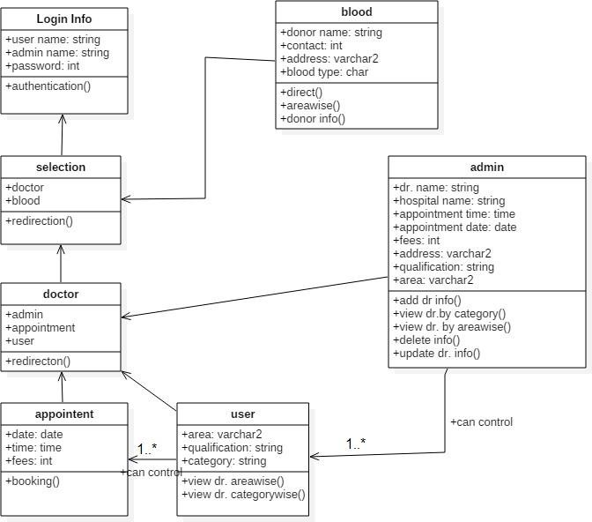

***Fig: - 1 Class Diagram of Doctor Near Me***

Doctor Near Me

###### Sequence Diagram:-

This is the UML sequence of Diagram of Doctor near me System, where admin will be able to login in their account using their credentials. After login user can manage all the operation on fees, Appointment, schedule, Doctor, Test. All the pages such as schedule, Doctor, Test are secure and user can access this page after login. The diagram below helps demonstrate how the login page works in a Doctor Appointment System.

The various objects in the Doctors, appointment, Blood, Selection, User and Test Page- interact over the course of the sequence, and user will not be able to access this page without verifying their identity.

This is the **UML sequence diagram of Doctor Appointment System** which shows the interaction between the object of Appointment, Blood, Doctor, Login, User, and

Selection.

The instance of class objects involved in this UML Sequence Diagram of Doctor near Me System are as Follows:-

* + Login Object
  + Selection Object
  + Blood Object
  + User Object
  + Doctor Object
  + Admin Object

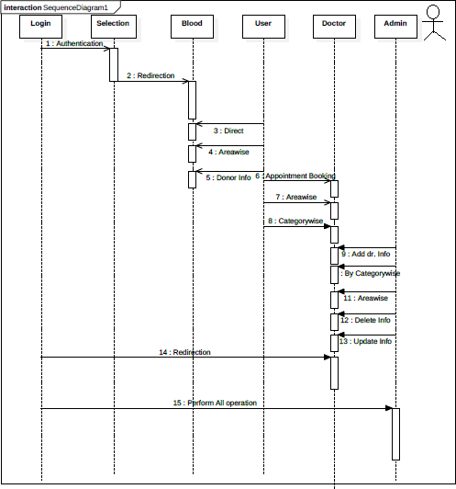

***Fig: -2 Sequence Diagram of Doctor Near Me***

###### Use case Diagram:-

This Use Case Diagram is a graphic depiction of the interaction among the element of Doctor Appointment System. It represents the methodology used in system analysis to identify, Clarify and organize system requirements of Doctor Appointment System.

The main actors of Doctors Appointment System in this Use case Diagram are: Admin, System User, Doctor, and Patient, who perform the different type of use cases such as Manage Doctors, Manage Appointment, Manage Booking, Manage fees, Manage schedule, Manage Blood, Manage Users and Full doctor Appointment System Operation.

Major element of the UML use case diagram of Doctor near me System is shown on the use case diagram:-

The relationship between and among the actor and the use cases of Doctor near Me System:-

* + **Admin Entity: -**Use cases of Admin are Manage Doctors, Manage Appointment, Manage Blood, Manage users and fullDoctor

Appointment System operation.

* + **User Entity: -** Use case of System is Manage Doctor, Manage Appointment, and Manage Blood, Check Appointment Status.
  + **Doctor Entity:** - Use cases of Doctor are checking Appointment, Creates Prescription, Search Patient, and Appointment History.

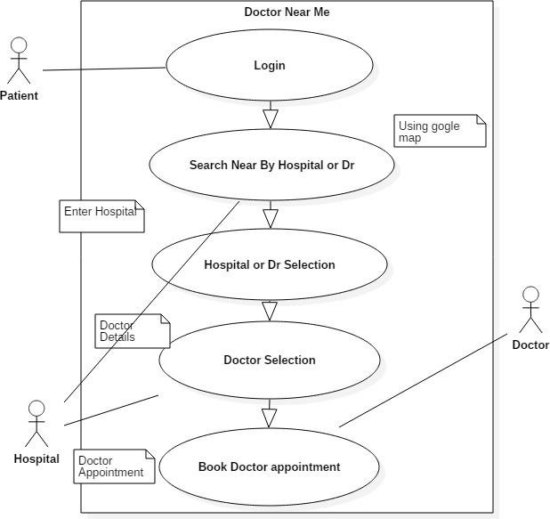

***Fig: - 3 Use Case Diagram of Doctor Near Me***

###### Activity Diagram:-

This is the **Activity UML diagram of Doctor Appointment System** which show the flow between the activities of Test, schedule, Doctor, Appointment, Blood. The main activity involve in this UML Activity Diagram of Doctor Appointment System are as follows:

* + Doctors activity
  + User Activity
  + Appointment Activity
  + Admin Activity
  + Blood Activity

###### Features Of the Activity UML Diagram of Doctor near me system:-

* In his Login Activity, Where admin will be able to login using their username and password. After login user can manage all the operation on Doctors and Blood.
* Appointment is secure and user can access these page after login.
* Admin user can search Test, description of a selected test; add info, update& delete.
* Its shows the activity flow of editing , adding & updating of schedule
* User will be able to search and generate Appointment, Blood, and doctor search by area wise or category wise.
* All object such as (appointment, doctor info, Blood, Dr. Search by area wise or category wise) are interlinked
* Its show the full description and flow of Appointment, Doctor, Blood.

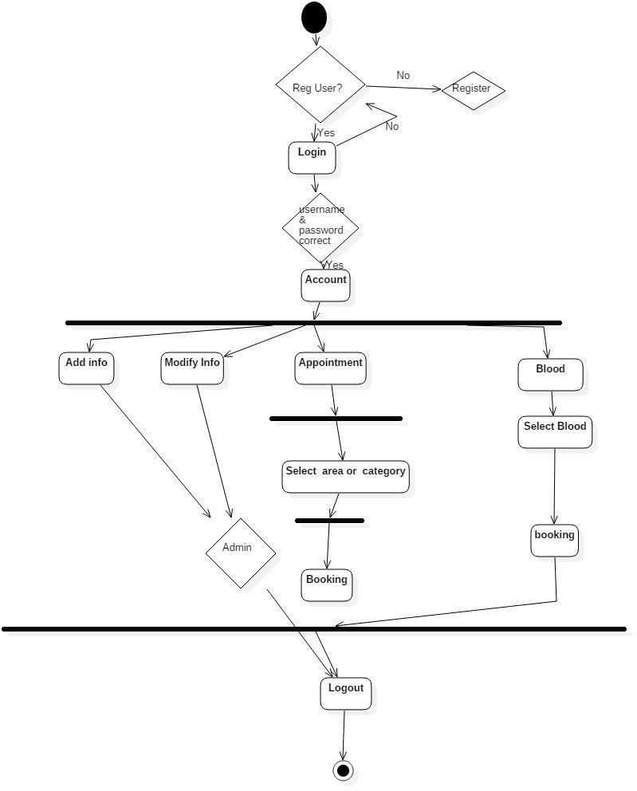

***Fig: - 4 Activity Diagram of Doctor Near Me***

Doctor Near Me

###### ER Diagram:-

The ER (Entity Relationship) Diagram represents the model of Doctor Appointment System Entity. The entity-relationship diagram of Doctor near me System. It’s used structure data and to define the relationship between structured data group of Doctor near me System functionalities. The Main entities of the Doctor, Appointment, Blood, fees and Doctor Info. Doctor Appointment System entities and their attributes:

* + **Doctor Entity: -** Attributes of Doctor are doctor-_id, doctor_name, doctor_specialist, and doctor_gender.
  + **Patient Entity: -** Attributes of Patient are Patient_name, Patient_no, Patient_gamil, Patient_gender, and Patient_dob.
  + **Admin Entity:** - Attributes of Admin entity are Admin_name, Admin_id, and Admin_password.
  + **Blood Entity:**- Attributes of blood entity are Blood_name andBlood_info

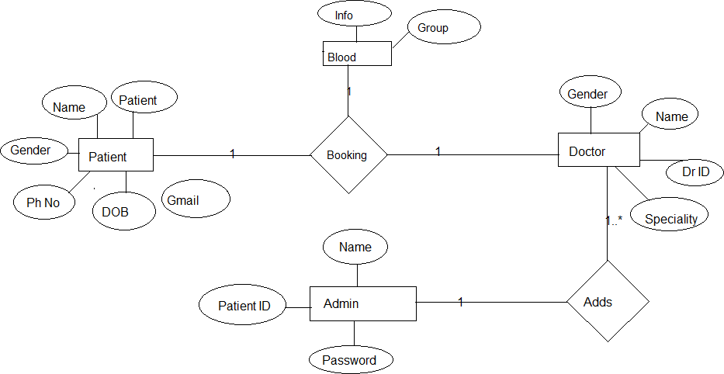

***Fig: - 5 ER Diagram of Doctor Near Me***

**Basic module:-**

**Login Info Module**: A Login, logging in or logging on is the entering of identifier information into a system by answer in order to access to that system.

**Doctor Module**: Redirect you to admin page/module or user module .As per login info.

**Appointment Module**: The process of booking of appointment is done through module.

**User Module**: User is the one that performs the action of booking, searching. Searching for appropriate Doctor or Blood firstly have category and secondly by area.

**Admin Module**: The admin works as the steering the android application as he is the one who add the Doctor based on the criteria of categories and area.

The qualification of doctor is verified & added to the app by the admin. If the doctor wishes to update any of his details he has to intimate the admin. The admin has the rights to insert, update and delete any operation from the application.

**Blood module**: The feature of blood donating and receiving is carried out through this module. Here in doctor enters his information which is then fetched when needed.

A needy can get blood directly from the location where he is, can search blood by area wise.

### Data design:

Data design is the first design activity, which results in fewer complexes, modular and efficient program structure. The information domain model developed during analysis phase is transformed into data structures needed for implementing the software.

The data objects, attributes, and relationships depicted in entity relationship diagrams and the information stored in data dictionary provide a base for data design activity. During the data design process, data types are specified along with the integrity rules required for the data. For specifying and designing efficient data structures, some principles should be followed.

### Data Integrity and Constraints:

###### Data integrity and constraints:

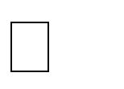CONSTRAINTS

* + - GUI is only in English.
    - Login and password is used for identification of user and there is no facility for guest. DATA INTEGRITY

1. Entity integrity
2. Referential integrity
3. Domain integrity

***Definition of data integrity:***

Data integrity can be maintained through the use of various errors. Checking methods and validation procedures

Data integrity is enforced in both hierarchical and relational database models.

1. Entity integrity:

This is concerned with the concept of primary keys. Every table must have its own primary key & that each has to be unique & not null.

1. Referential integrity:

This is the concept of foreign keys.

1. Domain integrity:

This states that all columns in a relational database are in a defined domain.

**Data integrity and constraints: Login:**

|  |  |  |  |
| --- | --- | --- | --- |
| **Login** | **Data type** | **Constraints** | **Size** |
| Login_id | Numeric | Primary Key | 20 |
| Login_Username | Varchar | Not Null | 30 |
| Login_Password | Numeric | Not null | 04 |

**Doctor:**

|  |  |  |  |
| --- | --- | --- | --- |
| **Doctor** | **Data type** | **Constraints** | **Size** |
| Doctor_id | Numeric | Primary key | 20 |
| Doctor_name | Varchar | Not Null | 20 |
| Doctor_gaender | Char | Not Null | 10 |
| Doctor_speciality | Varchar | Not Null | 30 |
| Doctor_qualification | Varchar | Not Null | 40 |
| Doctor_fees | Numeric | Not Null | 04 |

##### Appointment:

|  |  |  |  |
| --- | --- | --- | --- |
| **Appointment** | **Data type** | **Constraints** | **Size** |
| Time | Numeric | Primary key | 02 |
| Date | Numeric | Not Null | 04 |
| Fees | Numeric | Not Null | 04 |

**User:**

|  |  |  |  |
| --- | --- | --- | --- |
| **User** | **Data type** | **Constraints** | **Size** |
| User_name | Varchar | Primary key | 20 |
| User_no | Numeric | Not Null | 10 |
| User_gmail | Varchar | Not Null | 20 |
| User_dob | Numeric | Not Null | 10 |
| User_gender | Varchar | Not Null | 10 |

##### Admin:

|  |  |  |  |
| --- | --- | --- | --- |
| **Admin** | **Data type** | **Constraints** | **Size** |
| Admin_name | Varchar | Primary key | 20 |
| Admin_id | Numeric | Not Null | 20 |
| Admin_password | Varchar | Not Null | 10 |

**Blood:**

|  |  |  |  |
| --- | --- | --- | --- |
| **Blood** | **Data type** | **Constraints** | **Size** |
| Blood_name | Varchar | Primary key | 20 |
| Blood_info | Varchar | Not Null | 20 |

|  |  |  |  |
| --- | --- | --- | --- |
| Blood_quantity | Numeric | Not Null | 10 |

***Data structure:***

In a web-app development, data structure means a data organization, management and storage format that enable efficient access and modification. More precisely, a data structure is a collection of data values, the relationships among them, and the functions or operations that can be applied to the data.

###### Tree:-

In web-app development phase, a tree is a widely used abstract data type (ADT) or data

structure implementing this ADT that simulates a hierarchical tree structure, with a root value and sub-trees of children with a parent node, represented as a set of linked nodes. A tree data structure can be defined recursively (locally) as a collection of nodes (starting at a root node), where each node is a data structure consisting of a value, together with a list of references to nodes (the "children"), with the constraints that no reference is duplicated, and none points to the root.

###### Algorithms Design:-

STEP 1: start

STEP 2: login

STEP 3: Enter valid username & password

STEP 4: if password and username are correct then go to the Doctor info Else If fail go back the login page

STEP 5: After successful authentication user can Search/book appointment

STEP 6: User login correct then Select blood category

STEP 7: Booking the blood STEP 9: Logout/Stop

***SECURITY ISSUES:-***

* Security of data
* Ensure data accuracy’s
* Proper control of the higher officials
* Minimize manual data entry
* Minimum time needed for the various processing
* Greater efficiency
* Better service
* User friendliness and interactive
* Minimum time required

1. Privilege Escalation:

Software programs often have bugs that can be exploited. These bugs can be used to gain access to certain resources with higher privileges that can bypass security controls.

1. Virus:

The term "virus" has been used as a catchall phrase for many threats.

Essentially, a virus is a computer program that, like a medical virus, has the ability to replicate and infect other computers. Viruses are transmitted over networks or via USB drives and other portable media.

1. Worm:

A worm is a specific type of virus. Unlike a typical virus, it's goal isn't to alter system files, but to replicate so many times that it consumes hard disk space or memory. Worm victims will notice their computers running slower or

1. Trojan:

Horses, commonly referred to as Trojan, are programs. They masquerade as normal, safe applications, but their mission is to allow a hacker remote access to your computer. In turn, the infected computer can be used as part of a denial of service attack and data theft can occur. A particularly nasty Trojan is a keystroke logger than can be used to capture passwords, credit card numbers and other sensitive information.

1. Spyware:

Usually invades computers through software downloads. Shareware and freeware downloads, in addition to peer-to-peer file sharing are typical infection points. Like Trojans, spyware can pilfer sensitive information, but are often used as advertising tools as well. The intent is to gather a user's information by monitoring Internet activity and transmitting that to an attacker.

# IMPLEMENTATION AND TESTING

### Implementation Approaches

Planning is the most vital aspect of this project. To implement the following project we had to gradually take a procedural approach. The entire project was highly dependent on the technique of each and every implementation aspect. The Project is basically implemented through ‘Android Studio’ and the language used in it was

‘Java’ & its design was structured through ‘xml’.

The Database Connectivity plays an important role in the back end of the project. The Android Operating System should be above 5.0 i.e. Lollipop Version for the most optimum performance of the project. This project is entirely based on the android platform and is made much convenient for the user to understand the application and its working procedures.

### ADOPTED METHODOLOGY

##### Iterative Model:

An iterative life cycle model does not attempt to start with a full specification of requirements. Instead, development begins by specifying and implementing just part of the software, which is then reviewed to identify further requirements. This process is then repeated, producing a new version of the software at the end of the each iteration of the model.

Iterative process starts with a simple implementation of a subset of the software requirements and iteratively enhances the evolving versions until the full system is implemented. At the end of the each iteration, design modifications are made and new functional capabilities are added. The basic idea behind this method is to develop a system through repeated cycles (iterative) and in smaller portions at a time (incremental).

##### What is iterative model?

When you work with an Iterative Development model, the starting point doesn’t need a full requirements specification. The process starts with the design and development of just a limited part of the software, and the

iterative design process means that you return to expand and enhance this material repeatedly – until the entire system has been implemented and deployed.

The focus of Iterative Development is on delivering tested small features and then reviewing these interactively with the client, which means gradually implementing the actual system in discrete component parts.The design can be modified with each iteration, which means that the software evolves as new functional capabilities are developed. This can be particularly helpful when the client wants to test one level of the system in action before making detailed decisions on the next level of functionality.

In this iterative model, the whole requirement is divided into various builds. During each iteration the development module goes through the requirements, design, implementation and testing phases. Each subsequent release of the module adds function to the previous release. The process continues till the complete system is ready as per the requirement..The key to a successful use of an iterative software development lifecycle is rigorous validation of requirements, and verification & testing of each version of the software against those requirements within each cycle of the model. As the software evolves through successive cycles, tests must be repeated and extended to verify each version of the software.

Like other SDLC models, Iterative and incremental development has some specific applications in the software industry. This model is most often used in the following scenarios:

* Requirements of the complete system are clearly defined and understood.
* Major requirements must be defined; however, some functionalities or requested enhancements may evolve with time.
* There is a time to the market constraint.
* A new technology is being used and is being learnt by the development team while working on the project.
* Resources with needed skill sets are not available and are planned to be used on contract basis for specific iterations.
* There are some high-risk features and goals which may change in the future.

An iterative life cycle model which consists of repeating the following four phases in sequence:

Requirements phase:

**A Requirement phase** in which the requirements for the software are gathered and analyzed. Iteration should eventually result in a requirements phase that produces a complete and final specification of requirements.

Design phase:

**A Design phase,** In which a software solution to meet the requirements is designed. This may be a new design, or an extension of an earlier design.

Implementation and Test phase:

**An Implementation and Test phase**, when the software is coded, integrated and tested.

Review phase:

**A Review phase,** in which the software is evaluated, the current requirements are reviewed, and changes and additions to requirements proposed.

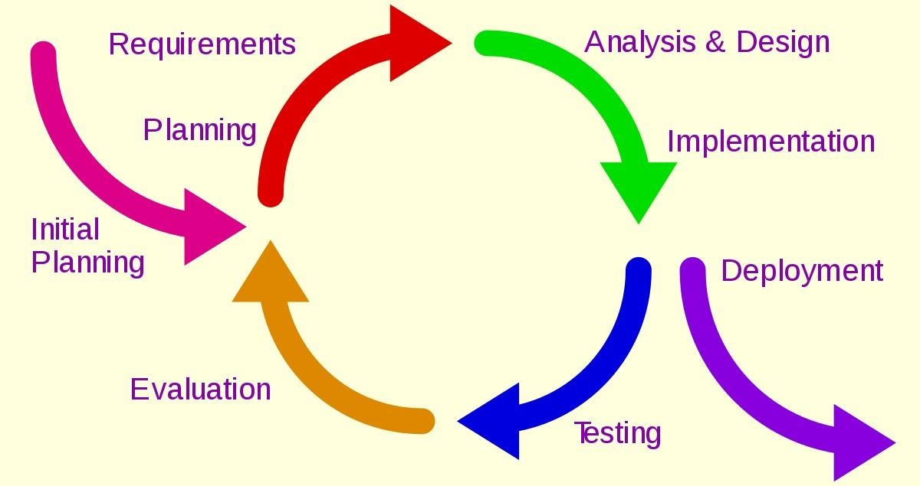

##### Iterative model

**Advantages:**

* In iterative model we can only create a high-level design of the application before we actually begin to build the product and define the design solution for the entire product. Later on we can design and built a skeleton version of that, and then evolved the design based on what had been built.
* In iterative model we are building and improving the product step by step. Hence we can track the defects at early stages. This avoids the downward flow of the defects.
* In iterative model we can get the reliable user feedback. When presenting sketches and blueprints of the products to users for their feedback, we are effectively asking them to imagine how the product will work.
* In iterative model less time is spent on documenting and , more time is given for designing.

**Disadvantages of iterative model:**

* Each phase of iteration is rigid with no overlaps.
* Costly system architecture or design issues may arise because not all requirements are gathered up front for the entire lifecycle.

**When to use iterative model:**

* Requirements of the complete system are clearly defined and understood.
* When the project is big.
* Major requirements must be defined; however, some details can evolve with time.
  1. ***Coding details and Code Efficiency***

##### Source Code:-

**Android Manifest.xml**

*<?*xml version="1.0" encoding="utf-8"*?>*

<manifest xmlns:android=["http](http://schemas.android.com/apk/res/android):[//schemas.android.com/apk/res/android"](http://schemas.android.com/apk/res/android) package="com.example.cec_03.doctor_near_me">

<application android:allowBackup="true" android:icon="@mipmap/ic_launcher" android:label="@string/app_name" android:roundIcon="@mipmap/ic_launcher_round" android:supportsRtl="true" android:theme="@style/AppTheme">

<activity android:name=".User"></activity>

<activity android:name=".Selection" />

<activity android:name=".DrById" />

<activity android:name=".DrByArea" />

<activity android:name=".DrByCate" />

<activity android:name=".MainActivity">

<intent-filter>

<action android:name="android.intent.action.MAIN" />

<category android:name="android.intent.category.LAUNCHER" />

</intent-filter>

</activity>

<activity android:name=".Login_Account" />

<activity android:name=".admin1" />

<activity android:name=".doc_info" />

<meta-data android:name="preloaded_fonts"

android:resource="@array/preloaded_fonts" />

</application>

</manifest>

**String.xml**

<resources>

<string name="app_name">DoctorNearMe</string>

<string name="doctor_information">doctor information</string>

<string name="add_doctor_information" translatable="false">Add Doctor Information</string>

<string name="view_doctor_by_category">View Doctor By Category</string>

<string name="view_doctor_by_areawise">View doctor by Area wise</string>

<string-array name="labels_array">

<item>Dentist</item>t

<item>Neurologist</item>

<item>Surgeon</item>

<item>Cardiologist</item>

<item>Ophthalmology</item>

<item>Physiotherapist</item>

<item>Dermatologist</item>

</string-array>

<string-array name="lab_array">

<item>Andheri</item>t

<item>Sakinaka</item>

<item>Ghatkopar</item>

<item>Chakala</item>

<item>Malad</item>

<item>MiraRoad</item>

<item>Powai</item>

</string-array>

</resources>

**MainActivity.java**

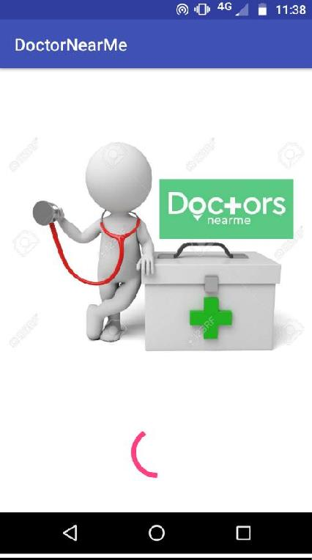

package com.example.cec_03.doctor_near_me; import

android.content.Intent;

import android.support.v7.app.AppCompatActivity; import android.os.Bundle;

import android.widget.ProgressBar; import android.widget.Toolbar;

public class MainActivityextends AppCompatActivity

{

private ProgressBarmprogress;

@Override

protected void onCreate(Bundle savedInstanceState)

{

super.onCreate(savedInstanceState); setContentView(R.layout.*activity_main*);

mprogress= findViewById(R.id.*pb1*); new Thread(new Runnable()

{

@Override

public void run()

{

doWork(); launchMainapp();

finish();

;

}

}).start();

}

private void doWork() {

for (intprogress = 0; progress < 300; progress +=10) { try{ Thread.*sleep*(200);

mprogress.setProgress(progress);

}catch (Exception e) {

}

}

}

private void launchMainapp() {

Intent intent = new Intent(MainActivity.this, Login_Account.class); startActivity(intent);

}

}

##### This is the coding of Splash Screen. The Starting activity of the application.

**Selection.java**

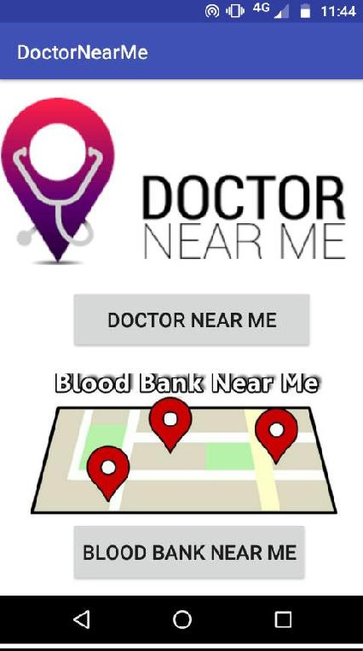

package com.example.cec_03.doctor_near_me; import

android.content.Intent;

import android.net.Uri; import android.os.Handler;

import android.support.v7.app.AppCompatActivity; import android.os.Bundle;

import android.view.View; import android.widget.Button;

public class Selection extends AppCompatActivity { Button b1,b2;

@Override

protected void onCreate(Bundle savedInstanceState) { super.onCreate ( savedInstanceState ); setContentView ( R.layout.*activity_selection*);

b1 = findViewById ( R.id.*button*);

b2 = findViewById ( R.id.*button2* );

b1.setOnClickListener(new View.OnClickListener() { @Override

public void onClick(View v) {

Intent intent = new Intent(Selection.this,User.class); startActivity(intent);

}

});

b2.setOnClickListener ( new View.OnClickListener () { @Override

public void onClick(View v) {

new Handler ( ).postDelayed ( new Runnable () { @Override public void run() {

Uri gmmIntentUri = Uri.*parse*( "geo:0,0?q=" );

Intent mapIntent = new Intent ( Intent.*ACTION_VIEW*,gmmIntentUri ); mapIntent.setPackage ( "com.google.android.apps.maps" );

startActivity ( mapIntent );

}

},1000 );

}

} );

}

}

##### This activity consist the selection for doctors near the user or the bloodbank.

**User.java**

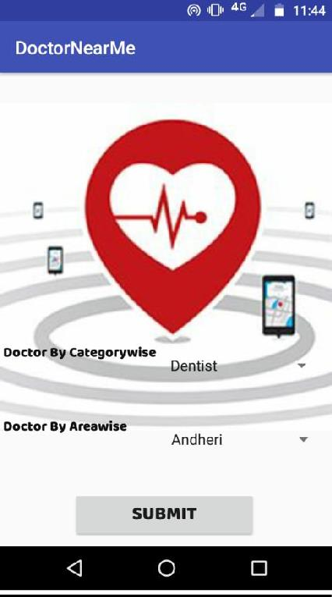

package com.example.cec_03.doctor_near_me;

import android.support.v7.app.AppCompatActivity; import android.os.Bundle;

import android.view.View;

import android.widget.AdapterView; import android.widget.ArrayAdapter; import android.widget.Button; import android.widget.EditText; import android.widget.Spinner;

public class User extends AppCompatActivityimplements AdapterView.OnItemSelectedListener {

Button b; Spinner sp,sp2 @Override

protected void onCreate(Bundle savedInstanceState)

{

super.onCreate(savedInstanceState); setContentView(R.layout.*activity_user*);

final Spinner spinner = findViewById ( R.id.*spinner1* ); ArrayAdapter<CharSequence> adapter

= ArrayAdapter.*createFromResource*( this, R.array.*labels_array*, android.R.layout.*simple_spinner_item*); adapter.setDropDownViewResource ( android.R.layout.*simple_spinner_dropdown_item*);

spinner.setAdapter ( adapter ); spinner.setOnItemSelectedListener ( this );

Spinner sp2 = findViewById ( R.id.*spinner2* ); ArrayAdapter<CharSequence>adapte = ArrayAdapter.*createFromResource*( this, R.array.*lab_array*,

android.R.layout.*simple_spinner_item*); adapte.setDropDownViewResource ( android.R.layout.*simple_spinner_dropdown_item*);

sp2.setAdapter ( adapte ); sp2.setOnItemSelectedListener ( this );

b = findViewById(R.id.*button3*); sp= findViewById ( R.id.*spinner1* );

sp2 = findViewById(R.id.*spinner2*);

}

@Override

public void onItemSelected(AdapterView<?>adapterView, View view, inti, long l) {

}

@Override

public void onNothingSelected(AdapterView<?>adapterView) {}}

##### This activity consists the spinner procedure of the user.

**Doc_info.java**

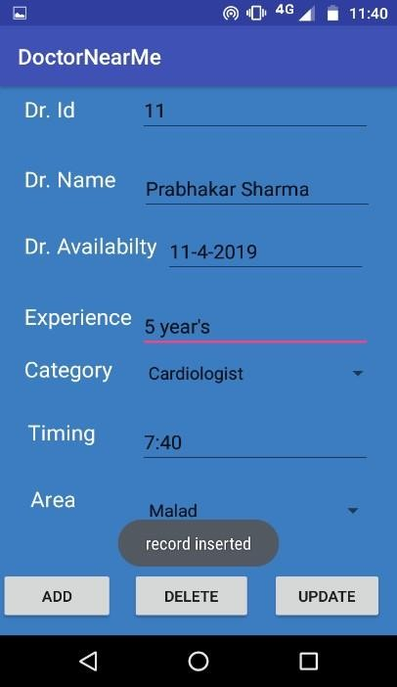

package com.example.cec_03.doctor_near_me; import android.app.DatePickerDialog;

import android.app.TimePickerDialog;

import android.support.v7.app.AppCompatActivity; import android.os.Bundle;

import android.view.View;

import android.widget.AdapterView;

import android.widget.AdapterView.OnItemSelectedListener; import android.widget.ArrayAdapter;

import android.widget.Button; import android.widget.DatePicker; import android.widget.EditText; import android.widget.Spinner; import android.widget.TimePicker; import android.widget.Toast;

import java.util.Calendar;

public class doc_infoextends AppCompatActivityimplements OnItemSelectedListener, View.OnClickListener {

EditTexte1, e2, e3, e4, e5; Button b1, b2, b3;

DatabaseHelperdh;

DatePickerDialogdpd;

TimePickerDialogtpd;

Calendar c; Spinner sp, sp1; @Override

protected void onCreate(Bundle savedInstanceState) { super.onCreate ( savedInstanceState ); setContentView ( R.layout.*activity_doc_info*);

final Spinner spinner = findViewById ( R.id.*spinner1* ); ArrayAdapter<CharSequence> adapter

= ArrayAdapter.*createFromResource*( this, R.array.*labels_array*, android.R.layout.*simple_spinner_item*); adapter.setDropDownViewResource ( android.R.layout.*simple_spinner_dropdown_item*);

spinner.setAdapter ( adapter ); spinner.setOnItemSelectedListener ( this );

final Spinner sp2 = findViewById ( R.id.*spinner2* ); ArrayAdapter<CharSequence>adapte = ArrayAdapter.*createFromResource*( this, R.array.*lab_array*, android.R.layout.*simple_spinner_item*); adapte.setDropDownViewResource ( android.R.layout.*simple_spinner_dropdown_item*);

sp2.setAdapter ( adapte ); sp2.setOnItemSelectedListener ( this );

b1 = findViewById ( R.id.*bt1* ); b2

= findViewById ( R.id.*bt2* ); b3 = findViewById ( R.id.*bt3* ); e1 = findViewById ( R.id.*et1* ); e2 = findViewById ( R.id.*et2* ); e3 = findViewById ( R.id.*et3* ); e4 = findViewById ( R.id.*et4* ); e5 = findViewById ( R.id.*et5* );

sp= findViewById ( R.id.*spinner1* ); sp1 = findViewById ( R.id.*spinner2* ); dh = new DatabaseHelper ( this ); e3.setOnClickListener(this); e5.setOnClickListener(this)

b1.setOnClickListener ( new View.OnClickListener () { @Override

public void onClick(View view) {

intid = Integer.*parseInt*( e1.getText ().toString () ); String name = e2.getText ().toString (); String ava = e3.getText ().toString (); String exp = e4.getText ().toString ();

String cate = (String) spinner.getSelectedItem (); String time = e5.getText ().toString ();

String area = (String) sp2.getSelectedItem ();

booleanans = dh.insertData ( id, name, ava, exp, cate, time, area ); if (ans == true) {

Toast.*makeText*( getApplicationContext (), "record inserted", Toast.*LENGTH_LONG*).show ();

} else {

Toast.*makeText*( getApplicationContext (), "record not inserted", Toast.*LENGTH_LONG*).show ();

}

}

} );

b3.setOnClickListener ( new View.OnClickListener () { @Override

public void onClick(View view) {

intid = Integer.*parseInt*( e1.getText ().toString () );

*/\**

*String name = e2.getText ().toString ();*

*String ava = e3.getText ().toString (); String exp = e4.getText ().toString ();*

*String cate = (String) spinner.getSelectedItem (); String time = e5.getText ().toString ();*

*String area = (String) spinner.getSelectedItem ();*

*\*/*

intc = dh.deleteData (id); if (c > 0) {

Toast.*makeText*( getApplicationContext (), c + "record deleted", Toast.*LENGTH_LONG*).show ();

} else {

Toast.*makeText*( getApplicationContext (), c + "record not deleted", Toast.*LENGTH_LONG*).show ();

}

}

} );

b2.setOnClickListener ( new View.OnClickListener () { @Override

public void onClick(View view) {

intid = Integer.*parseInt*( e1.getText ().toString () ); String name = e2.getText ().toString (); String ava = e3.getText ().toString (); String exp = e4.getText ().toString ();

String cate = (String) spinner.getSelectedItem (); String time = e5.getText ().toString ();

String area =(String) sp2.getSelectedItem ();

booleanans = dh.UpdateData ( id, name, ava, exp, cate, time, area ); if (ans == true) {

Toast.*makeText*( getApplicationContext (), "record updatad", Toast.*LENGTH_LONG*).show ();

} else {

Toast.*makeText*( getApplicationContext (), "record not updated", Toast.*LENGTH_LONG*).show ();

}

}

} );

}

@Override

public void onItemSelected(AdapterView<?> parent, View view, intposition, long id) { String text = parent.getItemAtPosition ( position ).toString ();

}

@Override

public void onNothingSelected(AdapterView<?> parent) {

}

public void onClick(View view) {

if (view == e3) {

dpd= new DatePickerDialog(this,

c = Calendar.*getInstance*();

new DatePickerDialog.OnDateSetListener() {

@Override

public void onDateSet(DatePicker view, intyear, intmonthOfYear, intdayOfMonth) {

e3.setText(dayOfMonth + "-" + (monthOfYear + 1) + "-" + year);

dpd.show();

}

if (view == e5)

{

}

}, c.get(Calendar.*YEAR*), c.get(Calendar.*MONTH*), c.get(Calendar.*DAY_OF_MONTH*));

c = Calendar.*getInstance*();*//it will return Current Time*

*// Launch Time Picker Dialog*

tpd= new TimePickerDialog(this, new TimePickerDialog.OnTimeSetListener() {

@Override

public void onTimeSet(TimePicker view, inthourOfDay, intminute) {

e5.setText(hourOfDay + ":" + minute);

}

}, c.get(Calendar.*HOUR_OF_DAY*), c.get(Calendar.*MINUTE*), true);

tpd.show();

}

}

@Override

public void onPointerCaptureChanged(booleanhasCapture) {

}}

##### The Database is used in it and for modifying the data in it , we used the date picker for selecting the date and time picker for selecting the time available.

**Code Efficiency**

Code efficiency is a broad term used to depict the reliability, speed and programming methodology used in developing codes for an application. Code efficiency is directly linked with algorithmic efficiency and the speed of runtime execution for software. It is the key element in ensuring high performance. The goal of code efficiency is to reduce resource consumption and completion time as much as possible with minimum risk to the business or operating environment. The software product quality can be accessed and evaluated with the help of the efficiency of the code used.

Code efficiency plays a significant role in applications in a high-execution-speed environment where performance and scalability are paramount.

One of the recommended best practices in coding is to ensure good code efficiency. Well- developed programming codes should be able to handle complex algorithms

**AdvantagesofCodeOptimization-**

* Optimized code has faster execution speed
* Optimized code utilizes the memory efficiently
* Optimized code gives better performance

## TechniquesforCodeOptimization-

1. Compile Time Evaluation
2. Common subexpression elimination
3. Dead Code Elimination
4. Code Movement
5. Strength Reduction
6. CompileTimeEvaluation-

Two techniques that falls under compile time evaluation are-

1. Constantfolding-
   * As the name suggests, this technique involves folding the constants by evaluating the expressions that involves the operands having constant values at the compile time.
   * **Example-**

Circumference of circle = (22/7) x Diameter

Here, this technique will evaluate the expression 22/7 and will replace it with its result 3.14 at the compile time which will save the time during the program execution.

1. ConstantPropagation-
   * In this technique, if some variable has been assigned some constant value, then it replaces that variable with its constant value in the further program wherever it has been used during compilation, provided that its value does not get alter in between.
   * **Example-**

pi = 3.14

radius = 10

Area of circle = pi x radius x radius

Here, this technique will substitute the value of the variables ‘pi’ and ‘radius’ at the compile time and then it will evaluate the expression 3.14 x 10 x 10 at the compile time which will save the time during the program execution.

1. Commonsub-expressionelimination-

The expression which has been already computed before and appears again and again in the code for computation is known as a common sub-expression.

As the name suggests, this technique involves eliminating the redundant expressions to avoid their computation again and again. The already computed result is used in the further program wherever its required.

**Example-**

|  |  |
| --- | --- |
| **Code before Optimization** | **Code after Optimization** |
| S1 = 4 x i S2 = a[S1]  S3 = 4 x j  S4 = 4 x i **// Redundant Expression**  S5 = n  S6 = b[S4] + S5 | S1 = 4 x i S2 = a[S1]  S3 = 4 x j S5 = n  S6 = b[S1] + S5 |

1. CodeMovement-

As the name suggests, this technique involves the movement of the code where the code is moved out of the loop if it does not matter whether it is present inside the loop or it is present outside the loop.

Such a code unnecessarily gets executed again and again with each iteration of the loop, thus wasting the time during the program execution.

**Example-**

|  |  |
| --- | --- |
| **Code before Optimization** | **Code after Optimization** |
| for ( int j = 0 ; j < n ; j ++)  {  x = y + z ; a[j] = 6 x j;  } | x = y + z ;  for ( int j = 0 ; j < n ; j ++)  {  a[j] = 6 x j;  } |

1. Deadcodeelimination-

As the name suggests, this technique involves eliminating the dead code where those statements from the code are eliminated which either never executes or are not reachable or even if they get execute, their output is never utilized.

**Example-**

|  |  |
| --- | --- |
| **Code before Optimization** | **Code after Optimization** |
| i = 0 ;  if (i == 1)  {  a = x + 5 ;  } | i = 0 ; |

1. Strengthreduction-

As the name suggests, this technique involves reducing the strength of the expressions by replacing the expensive and costly operators with the simple and cheaper ones.

**Example-**

|  |  |
| --- | --- |
| **Code before Optimization** | **Code after Optimization** |
| B = A x 2 | B = A + A |

Here, the expression “A x 2” has been replaced with the expression “A + A” because the cost of multiplication operator is higher than the cost of addition operator

**Testing Approach**

* 1. **Testing:**

***Generally, it has been specified thought for testing that:***

“Testing is the critical element of any software quality assurance and represents the ultimate review of specification, design and code generation.”

Software testing has a dual function; it is used to establish the presence of defects in program and it is used to help judge whether or not the program is usable in practice. Thus software testing is used for validation and verification, which ensure that software conforms to its specification and meets the need of the software customer.

Software testing is a process of executing a program or application with the intent of finding the software

bugs.

It can also be stated as the process of validating and verifying that a software program or application or product:

* + 1. Meets the business and technical requirements that guided it’s design and development
    2. Works as expected.
    3. Can be implemented with the same characteristics.

**Software testing is very important because of the following reasons:**

* + - 1. Software testing is really required to point out the defects and errors that were made during the development phases.
      2. It’s essential since it makes sure of the User’s reliability and their satisfaction in the application.
      3. It is very important to ensure the quality of the product. Quality product delivered to the users helps in gaining their confidence.
      4. Testing is necessary in order to provide the facilities to the customers like the delivery of high quality of product or software application which requires lower maintenance cost and hence results into more accurate, consistent and reliable results.
      5. Testing is required for an effective performance of software application or product.
      6. It’s important to ensure that the application should not result into any failures because it can be very expensive in the future or in the later stages of the development.

We have tested each and every module of our application. The errors which had occurred during implementation phase are solved in these testing phases thoroughly. Thus the amount of issues in the application is now minimal as compared to it before.

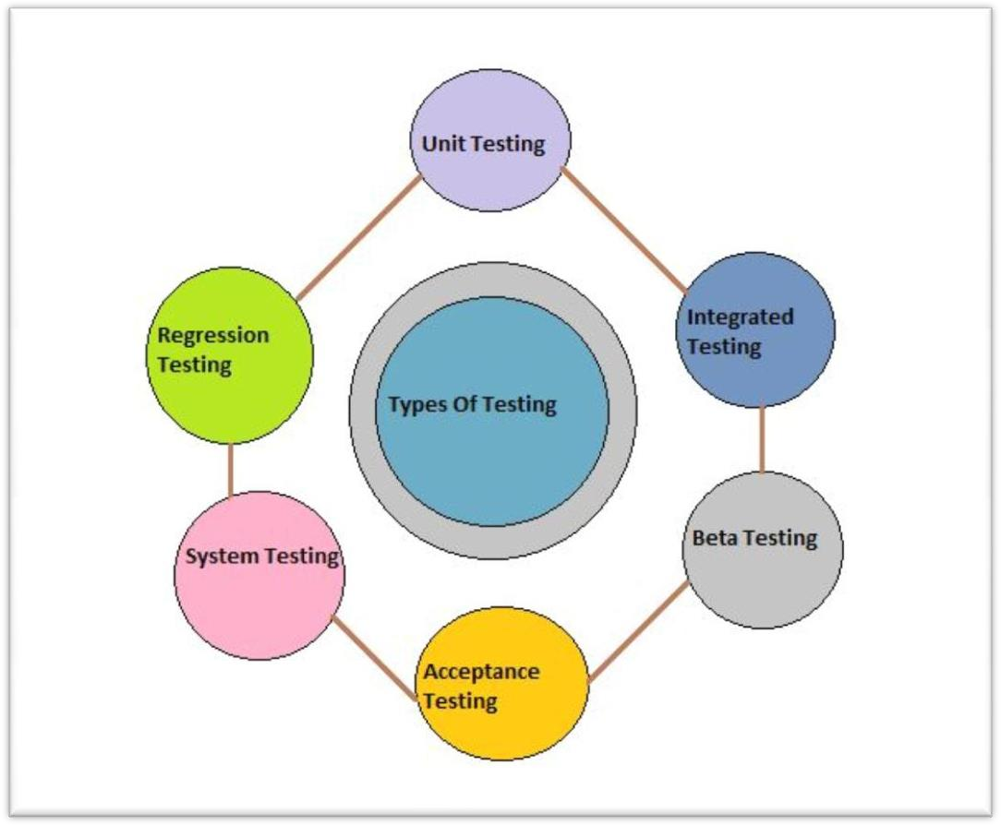

**Diagram 5:1 Types of Testing**

**White box testing**

* Structure-based testing technique is also known as **‘white-box’** or ‘glass-box’ testing technique because here the testers require knowledge of how the software is implemented, how it works.
* In white-box testing the tester is concentrating on how the software does it. For example, a structural technique may be concerned with exercising loops in the software.
* Different test cases may be derived to exercise the loop once, twice, and many times. This may be done regardless of the functionality of the software.
* Structure-based techniques can also be used at all levels of testing. Developers use structure-based techniques in component testing and component integration testing, especially where there is good tool support for code coverage.
* Structure-based techniques are also used in system and acceptance testing, but the structures are different. For example, the coverage of menu options or major business transactions could be the structural element in system or acceptance testing.

**Black box testing**

* + Specification-based testing technique is also known as **‘black-box’** or input/output driven testing techniques because they view the software as a black-box with inputs and outputs.
  + The testers have no knowledge of how the system or component is structured inside the box. In black-box testing the tester is concentrating on what the software does, not how it does it.
  + The definition mentions both functional and non-functional testing. Functional testing is concerned with what the system does its features or functions. Non-functional testing is concerned with examining how well the system does. Non-functional testing like performance, usability, portability, maintainability, etc.
  + Specification-based techniques are appropriate at all levels of testing (component testing through to acceptance testing) where a specification exists. For example, when performing system or acceptance testing, the requirements specification or functional specification may form the basis of the tests.

There are four specification-based or black-box technique:

* + [Equivalence partitioning](http://istqbexamcertification.com/what-is-equivalence-partitioning-in-software-testing/)
  + [**Boundary value analysis**](http://istqbexamcertification.com/what-is-boundary-value-analysis-in-software-testing/)
  + [Decision tables](http://istqbexamcertification.com/what-is-decision-table-in-software-testing/)
  + [**State transition testing**](http://istqbexamcertification.com/what-is-state-transition-testing-in-software-testing/)
* **Levels Of Testing**

Unit Testing

This type of testing is performed by developers before the setup is handed over to the testing team to formally execute the test cases. Unit testing is performed by the respective developers on the individual units of source code assigned areas.

|  |  |  |  |  |  |
| --- | --- | --- | --- | --- | --- |
| **Test ID** | **Test scenario** | **Value** | **Expected Result** | **Actual Result** | **Pass/fail** |
| A1 | Splash Screen | True | Working | Forward to next activity | Pass |
| A2 | Admin Login | Username=Prabhakar Password = mvlu | Working | Pass on to the Select options. | Pass |
| A3 | User Login | Username= (Only Alphabets )  Password= (Alphanumeric) | Working | Pass on to the Select options. | Pass |
| A4 | Register user | Username, Password | User Created | New user is created. | Pass |
| A5 | Database Connectivity | Data Store | Data To Be Stored | Information Is Stored | Pass |

* + I have checked each and every unit thoroughly and resolved the errors which arrived during the development of the unit in the project. The login section is divided into admin phase and user phase. Each having their own characteristics

Integrated Testing

Integration testing is defined as the testing of combined parts of an application to determine if they function correctly.

|  |  |  |  |  |  |
| --- | --- | --- | --- | --- | --- |
| **Test Case ID** | **Test scenario** | **Value** | **Expected Result** | **Actual Result** | **Pass/fail** |
| B1 | Splash Screen | True | Working | Forward to next activity | Pass |
| B2 | Doctor near me button | Show nearby doctors | To Show Selection options | Showing selection options. | Pass |
| B3 | Blood bank  near me  button | Show blood bank nearby. | To open  Google maps | Opens Google maps on click. | Pass |
| B4 | Add Doctor Information. | All the values added. | Record added to  the  database. | Record added successfully. | Pass |
| B5 | View All the Records | The values are shown | Record is shown. | The records are shown. | Pass |

* + When all the units are combined and tested together, then the workflow of the project is understood. The login credentials when matched, navigates to the corresponding pages for both user as well as admin. The data searched by the user is fetched in the Database for getting the outcome. The Blood bank option navigates to the map for the availability of Blood Bank nearby.

Beta Testing

This test is performed after alpha testing has been successfully performed. In beta testing, a sample of the intended audience tests the application. Beta testing is also known as **pre-release testing**.

In this project, the application merely has very less issues. The User Interface lacks stability and font mismatch. The navigation from one activity to another is unstable. The doctors availability is stored in the database through two ways i.e. category wise and area wise for better availability of the doctors. Through location and internet connectivity, the user can search for blood bank nearby the location with the help of Google maps. The security of both user and admin is maintained in login form.

Acceptance Testing

Acceptance tests are not only intended to point out simple spelling mistakes or interface gaps, but also to point out any bugs in the application that will result in system crashes or major errors in the application.

If we add login credentials wrong, the application would not provide further access for both admin and the user. The database errors which occurred during the entry of data during start are now cleared. The fatal exception occurring during the addition of images in the applications are also sorted out.

System Testing

System testing tests the system as a whole. Once all the components are integrated, the application as a whole is tested rigorously to see that it meets the specified Quality Standards. This type of testing is performed by a specialized testing team.

When the application is ready, the total modules of the application are tested on many systems, depending on their performances. The working of the activities, navigation, database connectivity, device inputs are tested in this phase. The Optimal result is then calculated and the required changes in the application are then made for enhancement of the application in the next phase.

|  |  |  |  |  |  |  |  |
| --- | --- | --- | --- | --- | --- | --- | --- |
| **7.3 Test Cases** | | | | | | | |
| **Test Case ID** | **Test Scenario** | **Test Steps** | **Test Data** | **Expected Result** | **Actual Result** | **Remark** |  |
| TC1 | Splash Screen |  |  |  |  |  |  |
| TC2 | Registrati on | Enter Username,  Password and Confirm Password.  Click on Register. | Username=  Prabhakar  Confirm Password=Mvlu  User must enter proper data | User should be registered | User successfull y registered. | Pass |  |
| TC3 | Check Login of User | Enter Username,  Password and Click on Login | Username= (As Per Set By User)  Password = (As Per Set By User) | User should be logged in. | Login Successful. | Pass |  |
| TC4 | SQL  Query | Insert, Update, Delete | The Data is provided. | Data Is  Modified | Data Modificati on Successful | Pass |  |
| 64 | | | | | | | |

|  |  |  |  |  |  |  |
| --- | --- | --- | --- | --- | --- | --- |
| TC5 | User Search | Doctor By Area wise and category wise | Accurate Doctors availability is to be shown. | The Correspondi ng Doctors are shown. | Doctors Data Is  Shown. | Pass |
| TC6 | Blood Bank & Map | Click On  Blood Bank Button | To Show The Blood  Bank nearby the user’s location | The Google maps will be opened | The Button will navigate to Google maps | Pass |

# COST ESTIMATION

##### *Cost Estimation Model:

A cost estimate is the approximation of the cost of a program, project, or operation. The cost estimate is the product of the cost estimating process.

##### The Development Mode:

There are several modes of software development .These different software development modes have cost- estimating relationships which are similar in form, but which yield significantly different cost estimates for software products of the same size. In the COCOMO Model, one of the most important factors contributing to a project's duration and cost is the Development mode. Every project is considered to be developed in one of three modes:

1. Organic Mode.
2. Semidetached Mode
3. Embedded Mode

To estimate the effort and development time, COCOMO use the same equations but with different coefficients (*a, b, c, d* in the effort and schedule equations*)* for each development mode. Therefore before using the COCOMO model we must be able to recognize the development mode of our project.

##### Organic Mode:

In the organic mode the project is developed in a familiar, stable environment and the product is similar to previously developed products. The product is relatively small, and requires little innovation. Most people connected with the project have extensive experience in working with related systems within the organization and therefore can usefully contribute to the project in its early stages, without generating a great deal of project communication overhead.

##### Semidetached Mode:

In this mode project's characteristics are intermediate between Organic and Embedded. "Intermediate" may mean either of two things:

* 1. An intermediate level of project characteristics.
  2. A mixture of the organic and embedded mode characteristics.

##### Embedded Mode:

In this development mode Project is characterized by tight, inflexible constraints and interface requirements. The product must operate within a strongly coupled complex of hardware, software, regulations, and operational procedures.

**Basic Model:**

The basic COCOMO equations take the form

**Effort Applied (E)** = ab(KLOC)bb**[person-months] Development Time (D)** = cb(Effort Applied)db**[months]**

**People Required (P)** = Effort Applied / Development time **[count]**

1. Compute the count-total which will be used to define the complexity of a project.

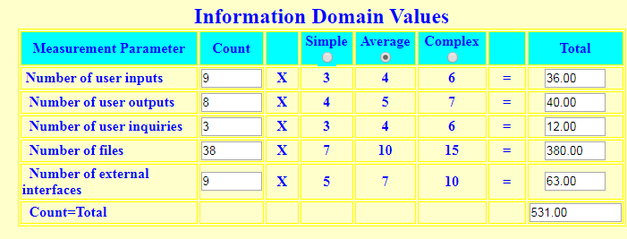

1. **Find the complexity adjustment values based on responses to the questions..**

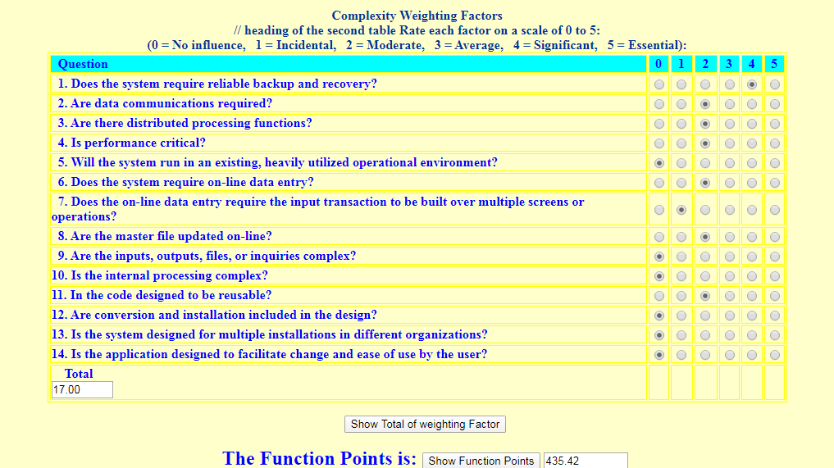

1. Select complexity of the software project:

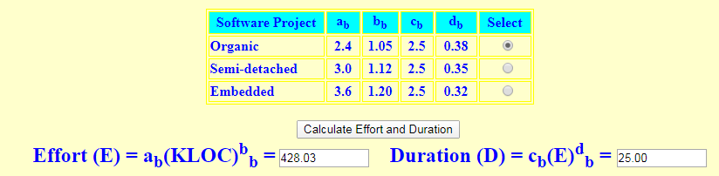

**Man-month = Unadjusted Function Point (UFP) / 18**

= 435 / 18

**= 24**

Average Programmer is paid Rs. 5,500 per month Total number of programmers: 2

**Cost per month = Average Programmer cost * No of programmers**

= 5,500 * 2

**= Rs.11,000 per month**

Total cost of Project = Cost per month * man-month

**= 11000 * 24**

**= Rs. 264,000**

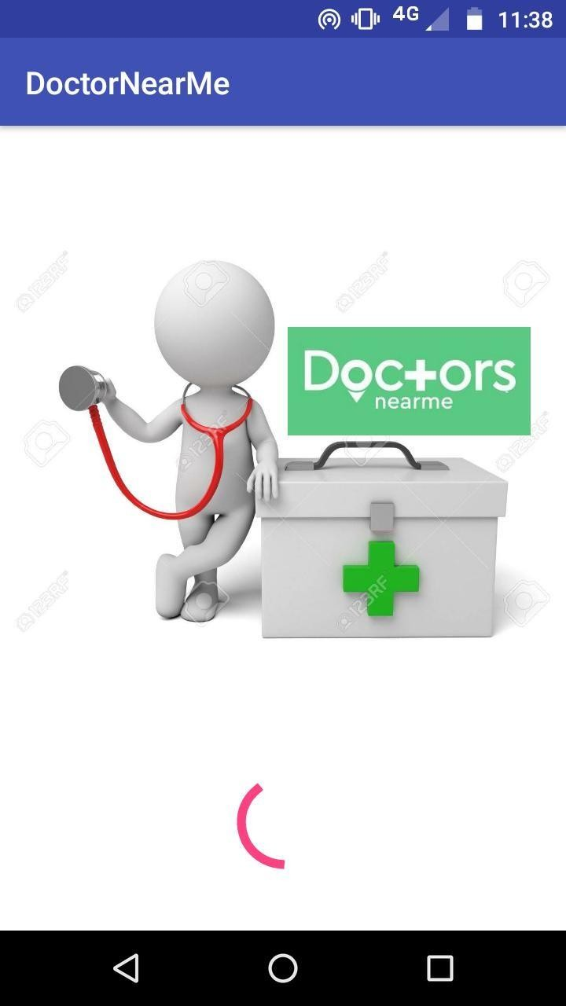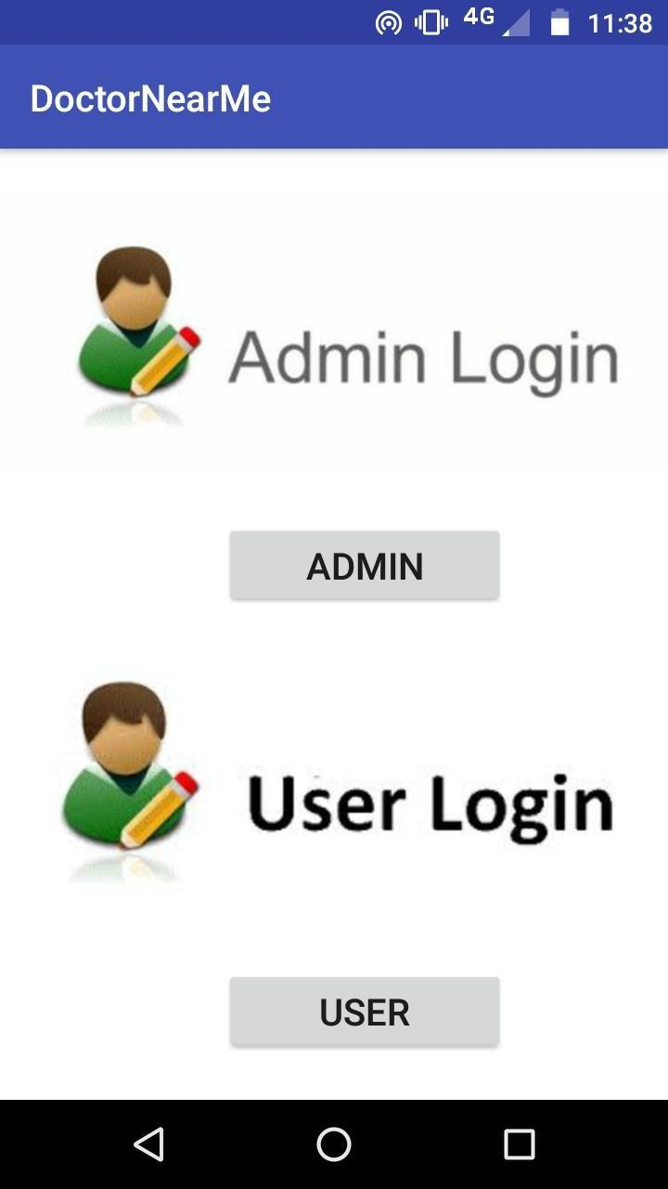

# RESULT AND DISCUSSION

#### Test Report

The Test Cases which were performed led to the checking of each and every module in the application.

The Splash Screen was tested continuing with the Login of both the admin as well as the user’s activity. The User will have options on selecting the doctors through two ways, or by combining both the ways.

The Database is tested by adding, inserting, updating and deletion of the record. The Data fetching process is also considered during the applications.

The User will search the doctors by area wise and category wise and the blood bank in the nearby location.

* + 1. ***Splash Screen B) Login Page***
       1. This is the start-up activity (B) This is the login page for both of the application. Admin and User.

1. ***Admin Login D) Admin Wrong Info***

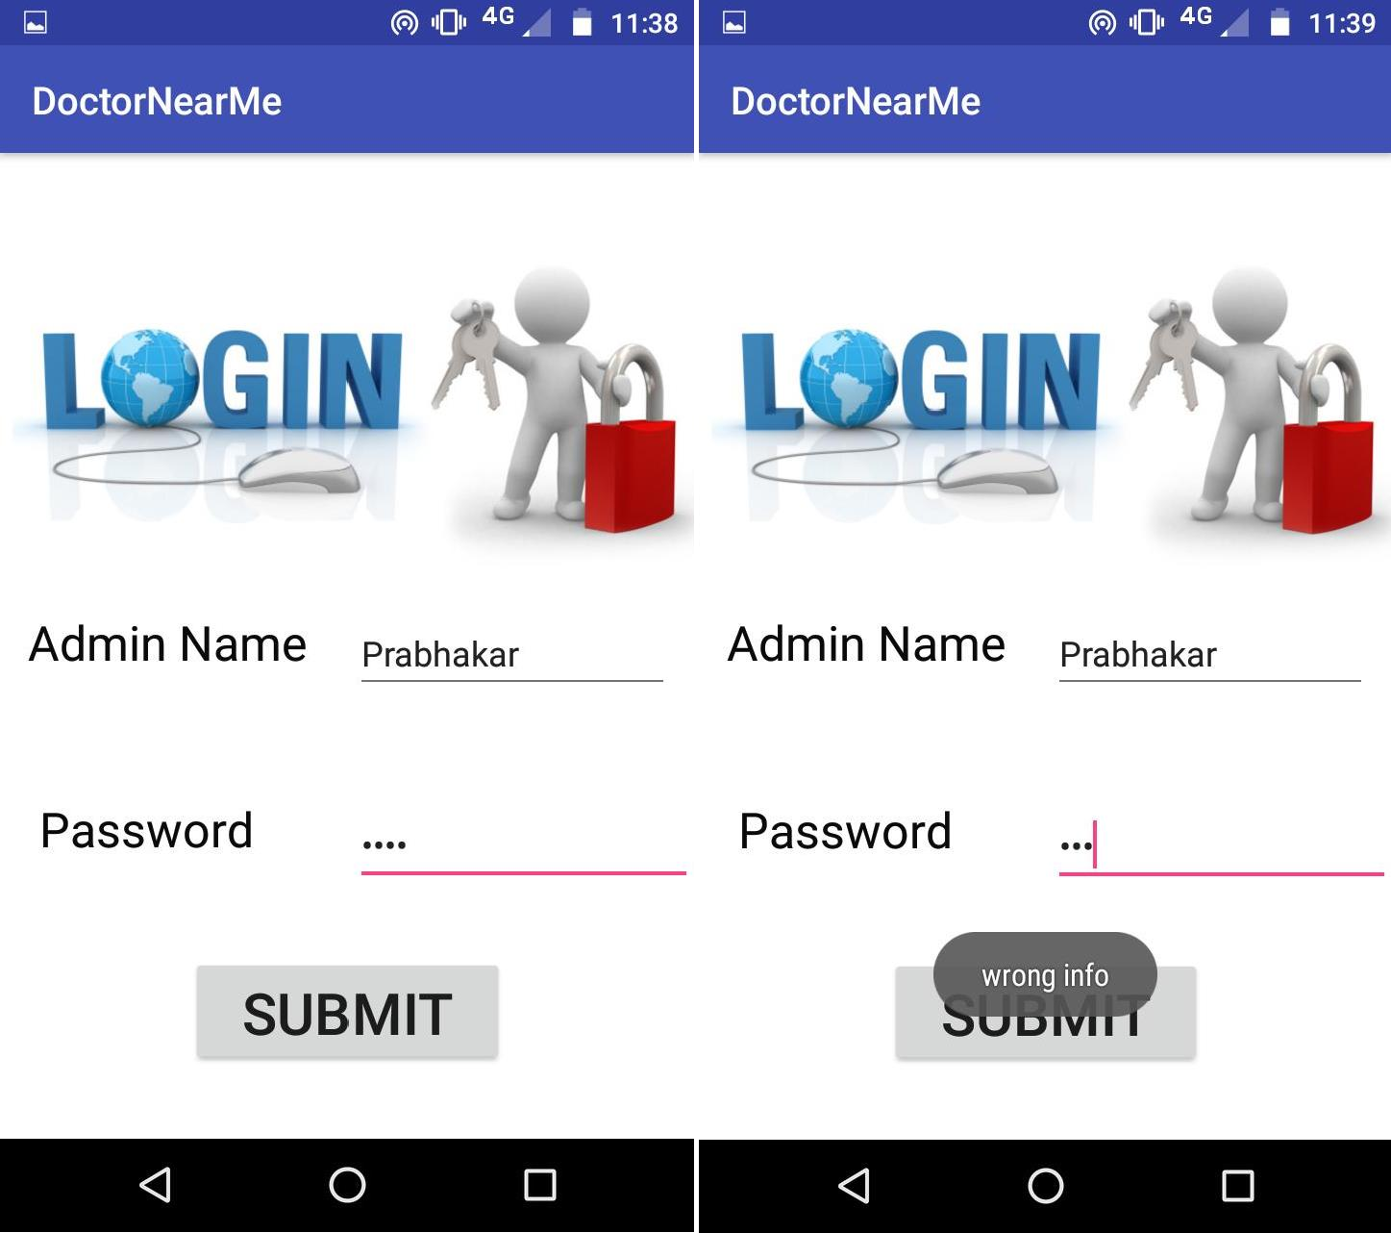

* + The Admin login page with wrong credentials will show

a toast message “wrong info”.

1. ***Database Activity F) Insert Activity***

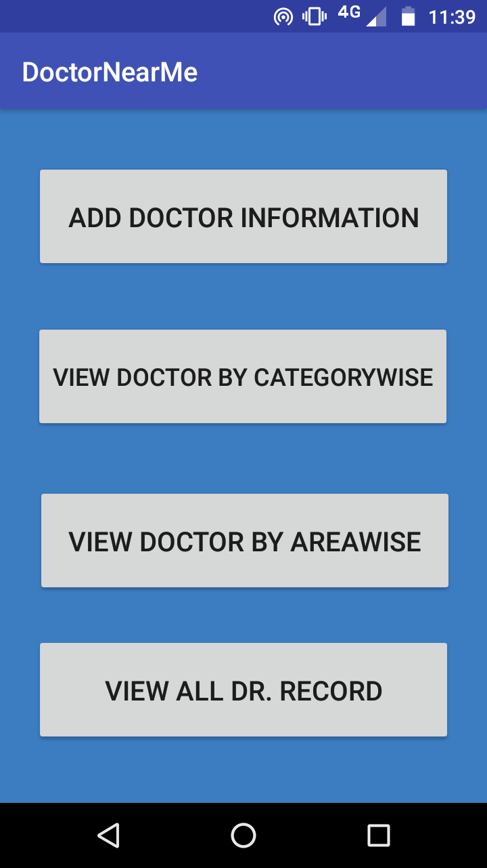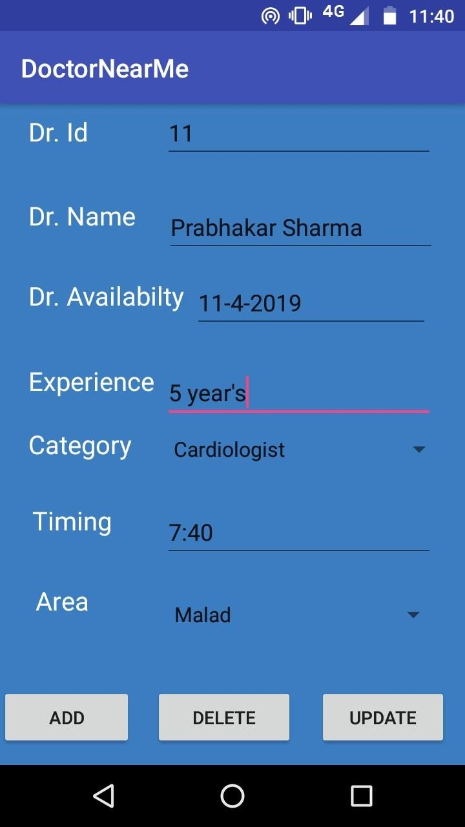

* + The Database Modifications options have: Add doctor information,

View Doctor By Category Wise, View Doctor By Area wise, View All Dr.Record.

1. ***Update Activity H) Delete Activity***

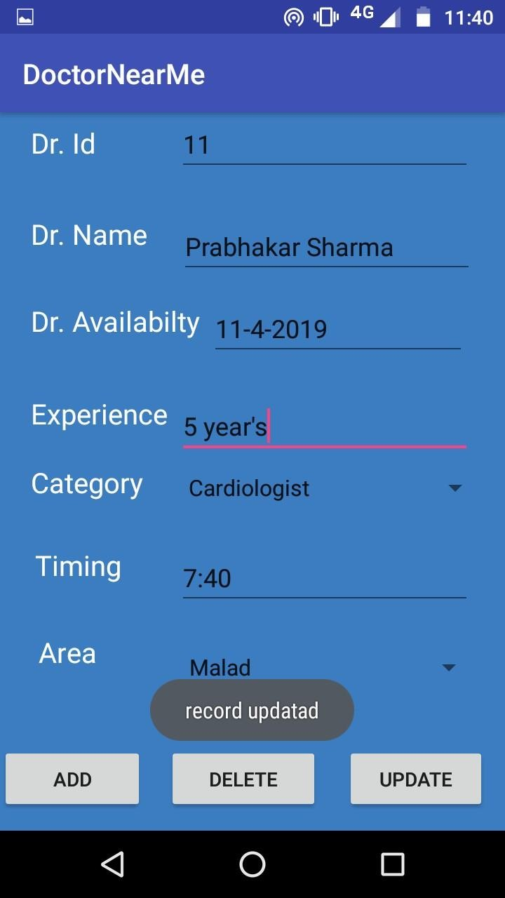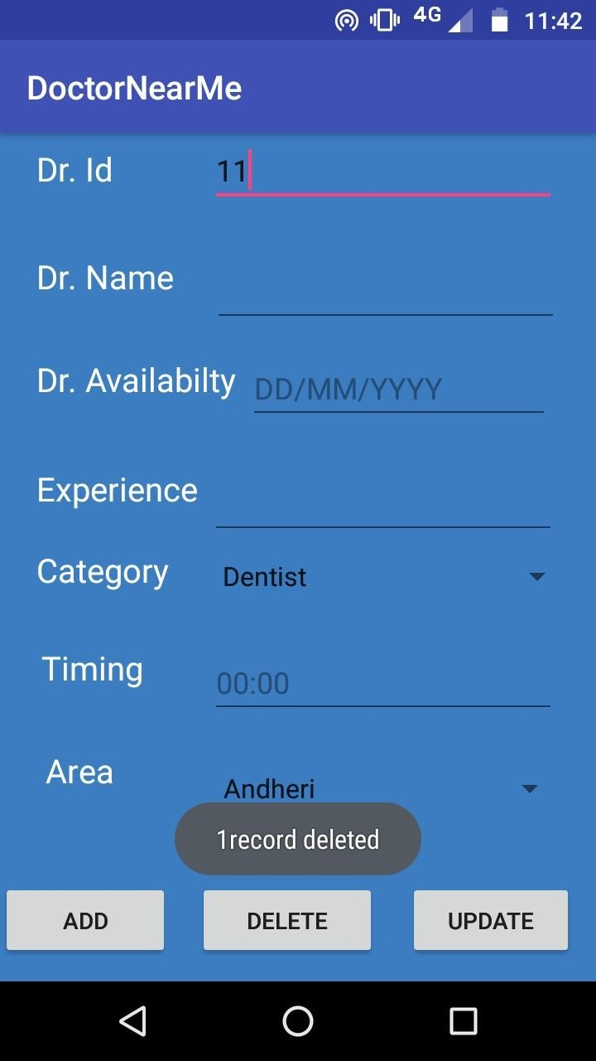

* + The Database Changes Are Shown Here.

***I) View Record Activity J) Empty Record***

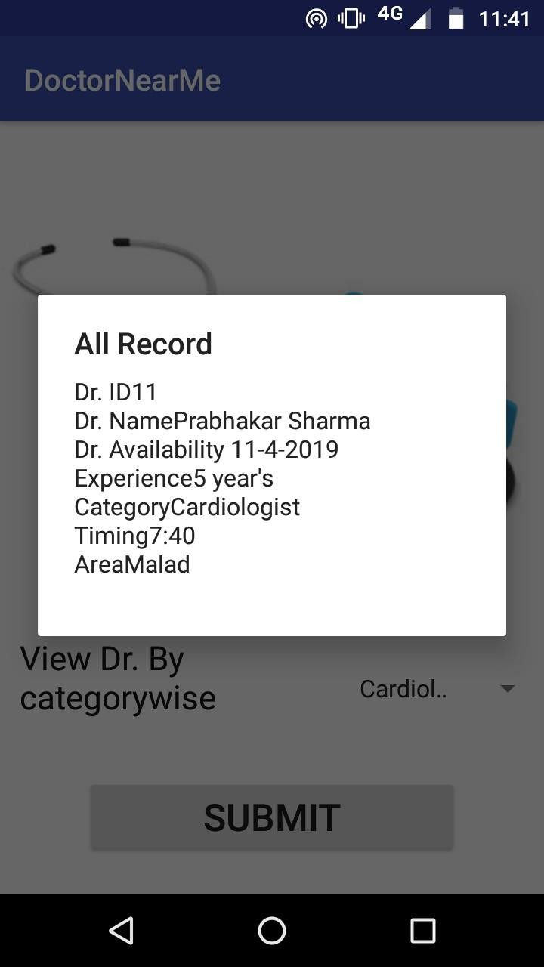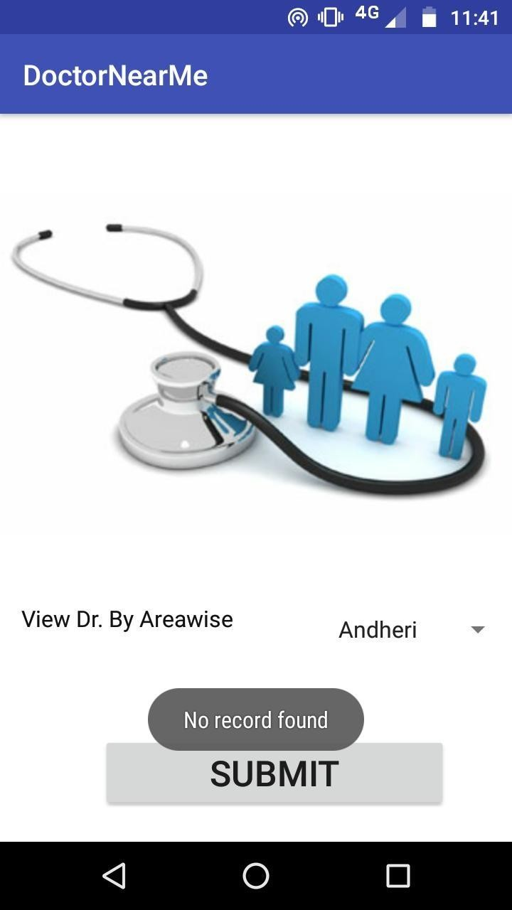

A Record is shown in the list format If No Record is present, then the toast No Record Found Is Shown.

***K) View By Area wise L) View By category wise***

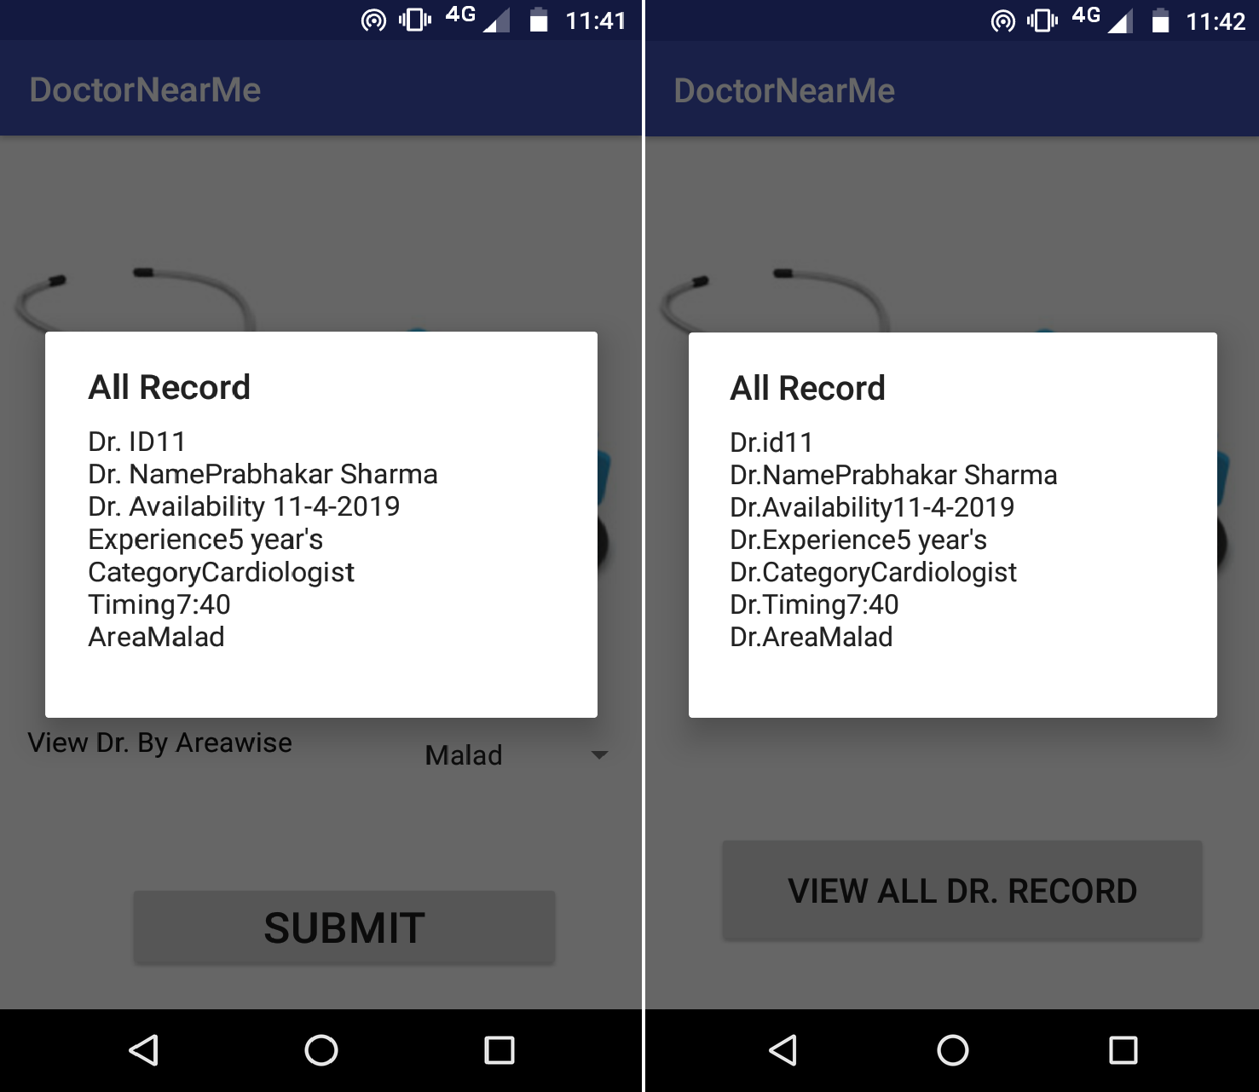

1. ***User Registration N) User Login***

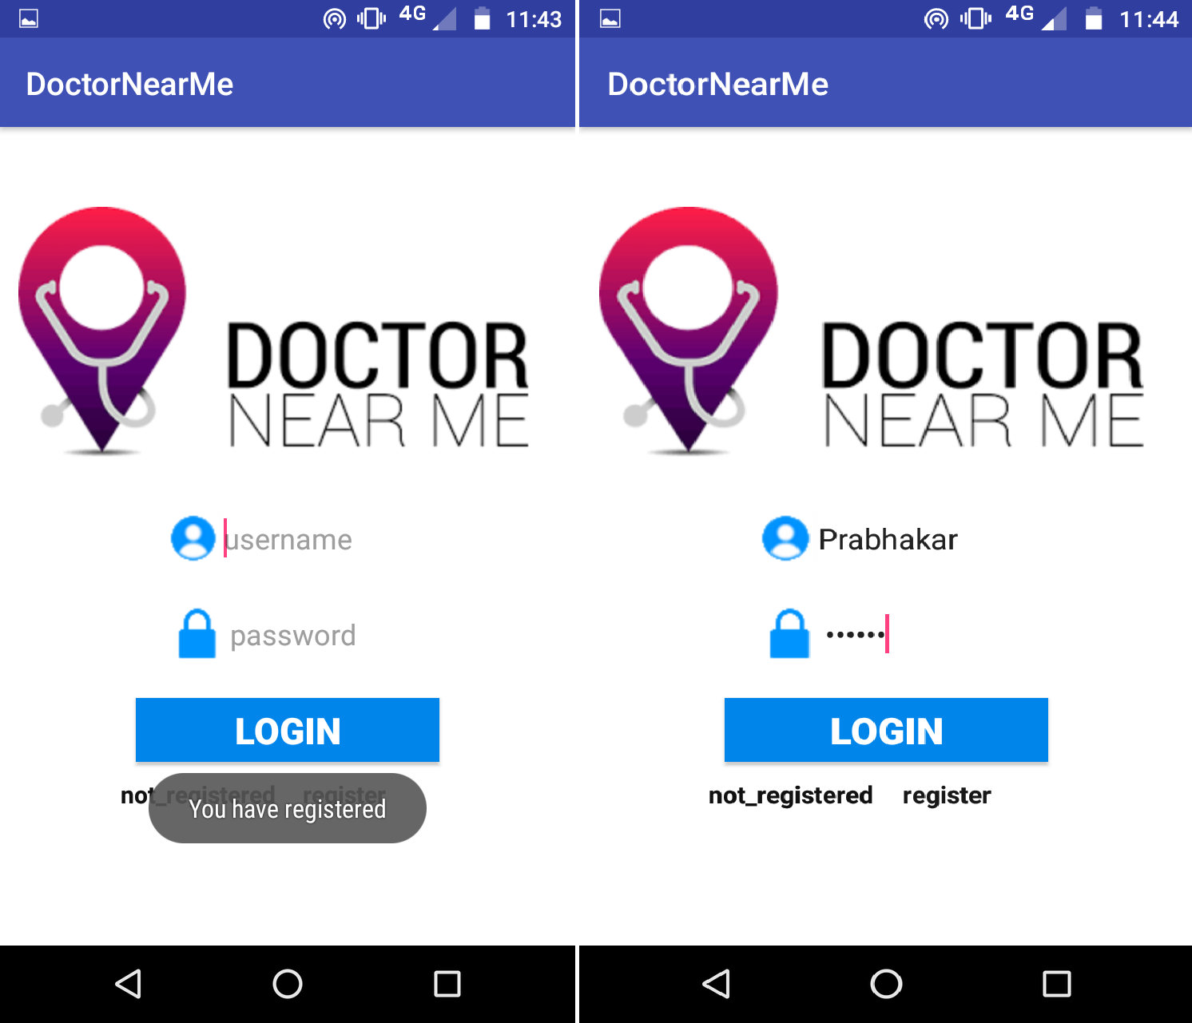

* + The registered login Id and Password Is Shown in the form of Toast.

***O) User Selection Activity P) Doctor View Options***

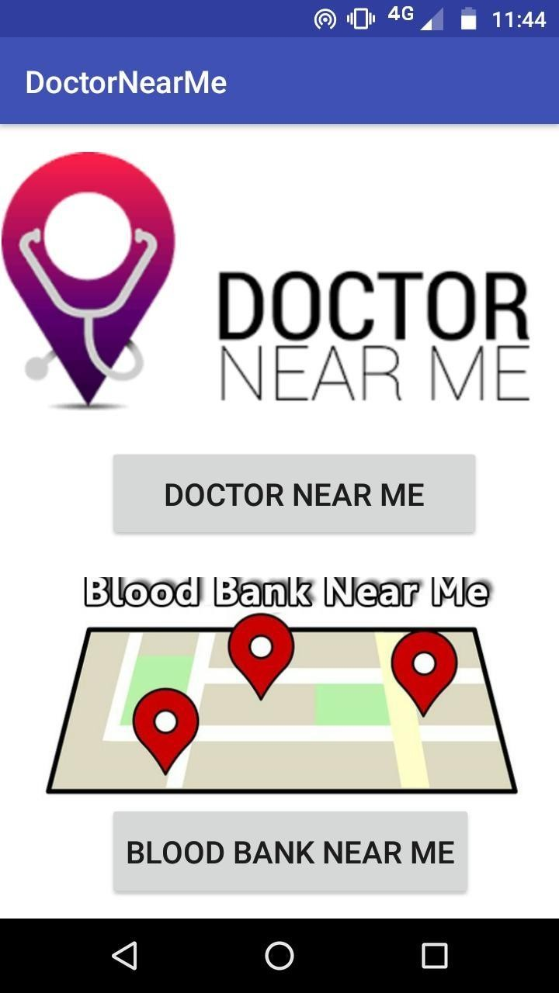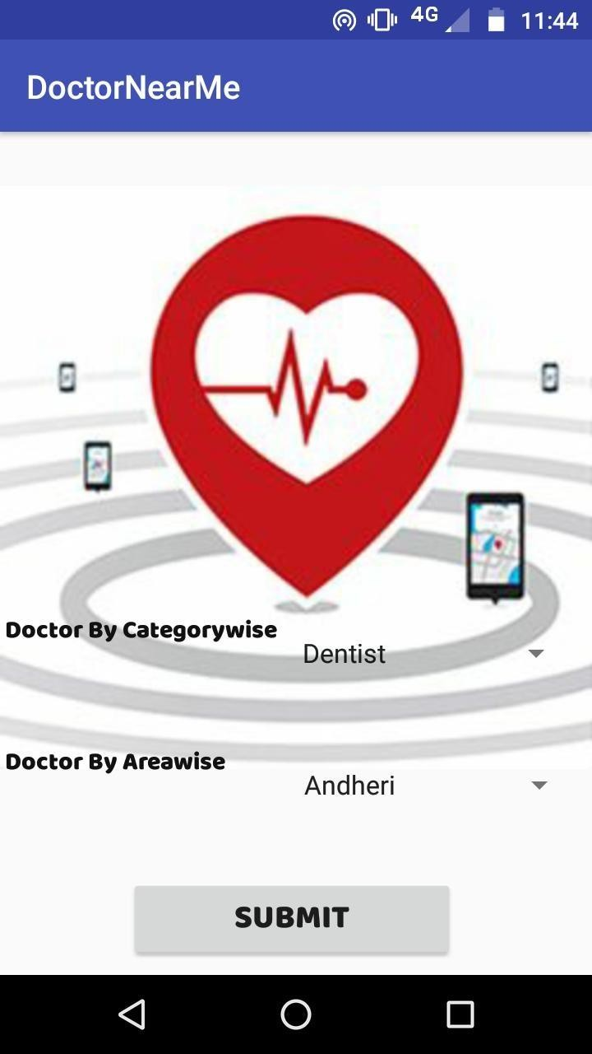

The User can select as required. The Doctor’s Choices can be

submitted**.**

1. ***Record View Page R) Blood Bank map***

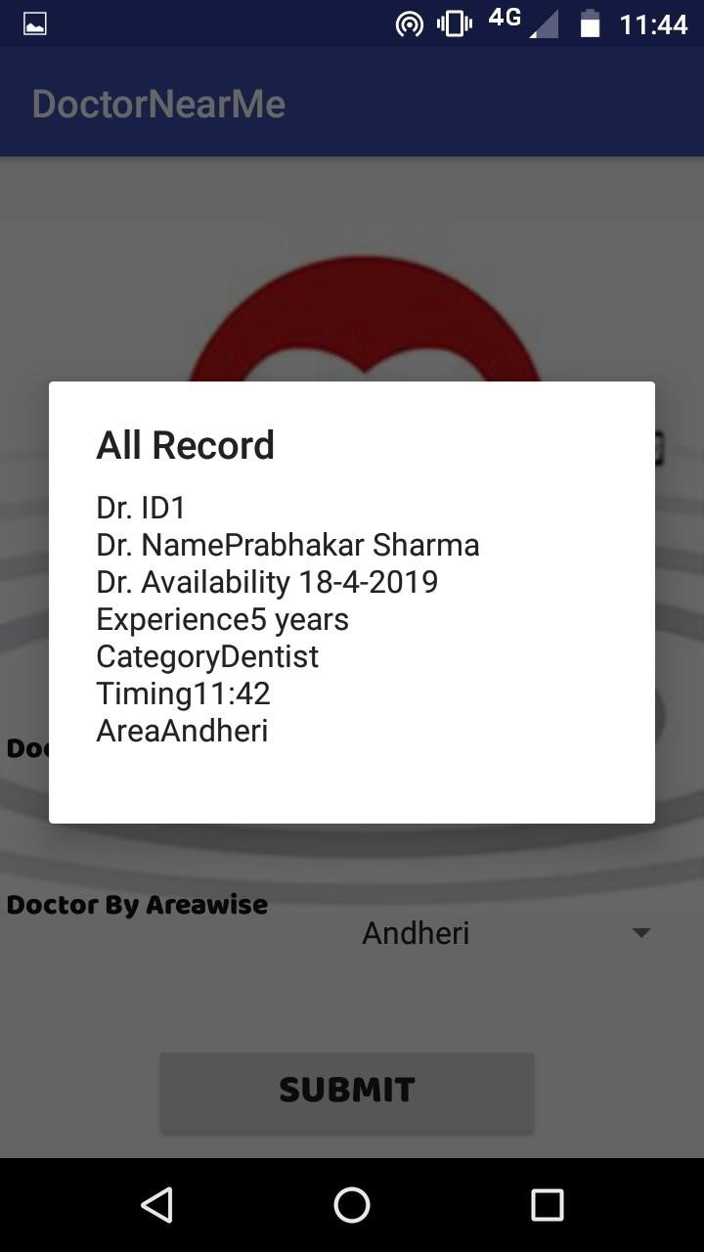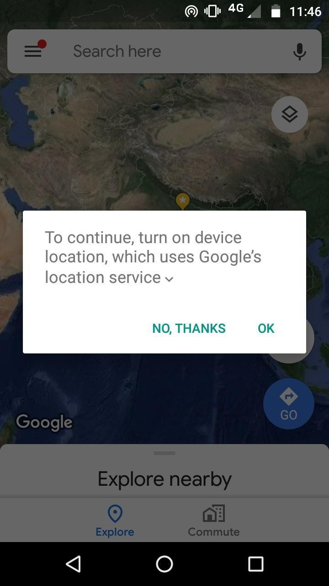

* + The Doctor’s availability and available doctor is shown.

1. ***Blood Bank Map Location T) Blood Bank Near By Option***

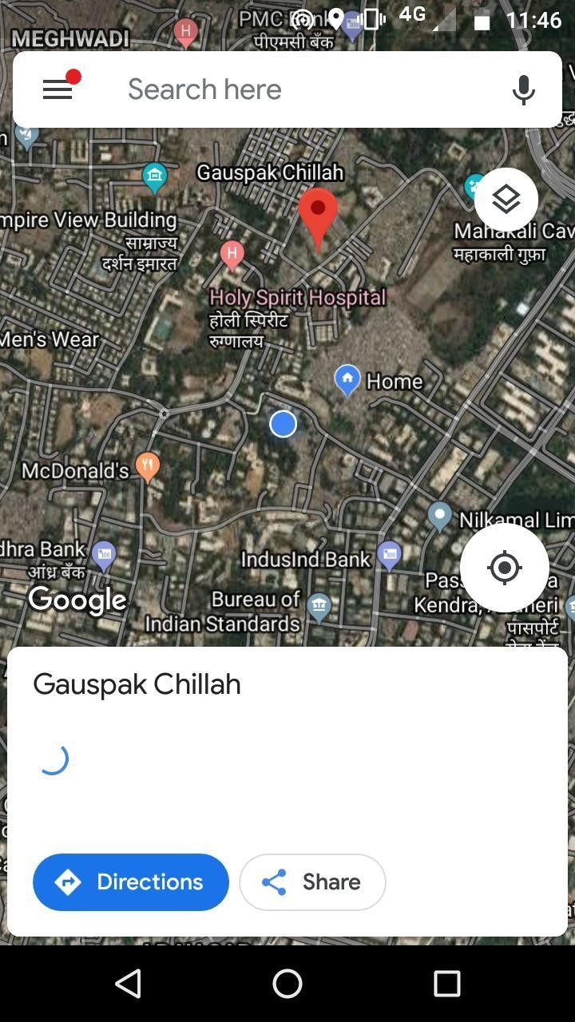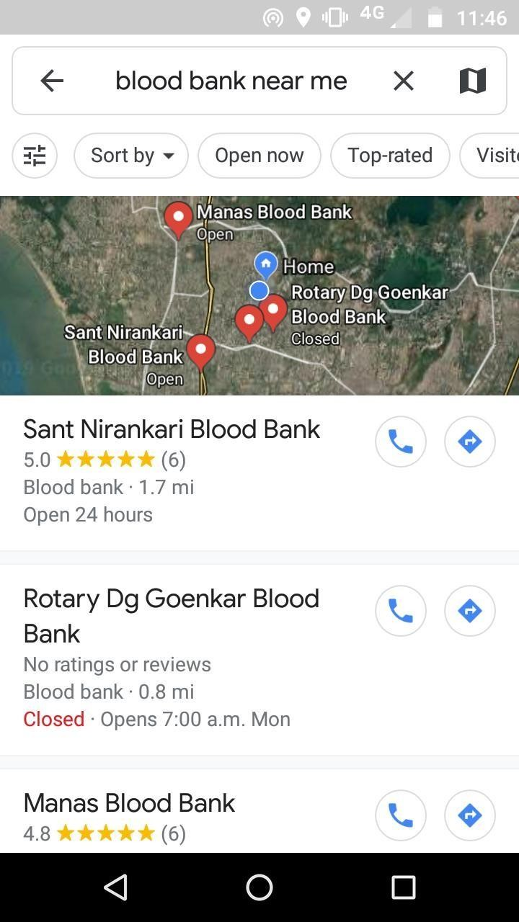

* + Nearby Blood Banks are shown in the Google maps.

#### User Documentation

**Navigation:**

* This is the Home Page . The User will first register his/her account on the application and sign in to use the application.

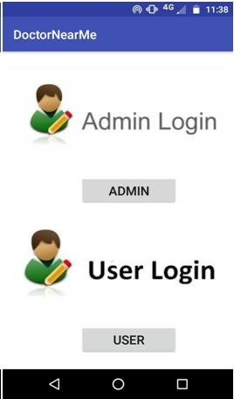

**CLICK HERE**

* The user will then get 2 options to search for the doctor’s availability and to search for blood bank present nearby its location.

**Search for Doctors:**

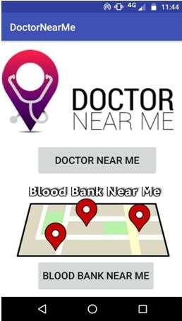

**Available**

**options**

**with**

**two**

* The user can search for the doctors through category or through area wise. Depending on the user’s necessity.
* In the “Doctor By Categorywise ” user can select other options which are made available
* In the “Doctor By Areawise” user can select other locations according to their need.

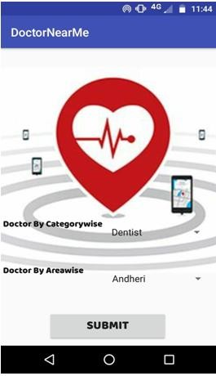

**Click on the**

**arrow**

* + After using the required options click on the submit button
  + The Doctor’s availability and available doctor is shown.
  + The Page with the appropriate details of the doctor will get displayed.

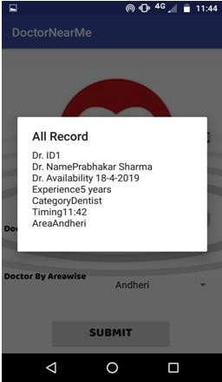

**Search for Blood Banks:**

* + - After clicking on the second button “BLOOD BANK NEAR ME” user will get the access for the google maps to search the required banks available.

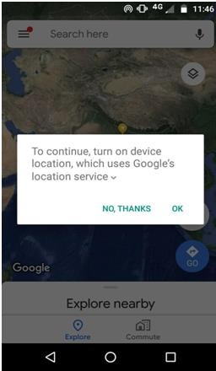

* + - Users should not forget to turn on the device location.
    - The Google Map will get open.
    - Search for the required blood bank available nearby users locations.

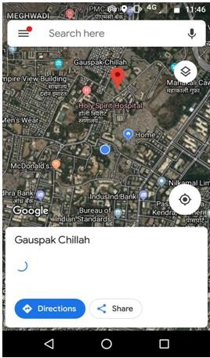

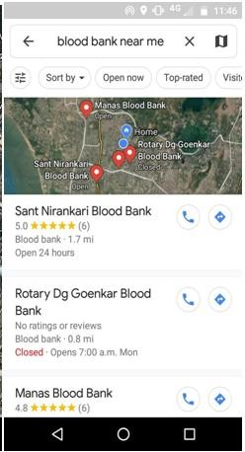

* + Nearby Blood Banks are shown in the Google maps.
  + For all these modules to work, internet connectivity and location is mandatory in the user’s device.

# CONCLUSIONS

#### Conclusion

This project has the main focus on finding the doctors available nearby from the user’s location. This will make the user time convenient and easy to use the application. The user can place an appointment for the patient in the application according to the suitable required time to the patient and the doctor.

The whole system has been divided into major parts i.e. Admin and User. Both of them have their own roles to perform and response accordingly. The user can search the doctors as per requirement in two categories i.e. doctors by area wise and doctors by categories.

The User can also search the blood near him/her with the help of location. The system will manage the Doctors, Patients, Schedules of Doctors and The Appointment of Patients efficiently.

Additions of the admin and doctor modules in the android application are included in future work. That would help the doctor to register on the application and perform all the tasks on the app. The admin would be able to use the app for managing the details of the patients and the doctors instead of using the website.

A payment or some amount may be charged to the users/patients while making an appointment to avoid the unethical users. As many users only register themselves just for fun and has no concern by making an appointment.

Some more future directions are the improvements in the patient’s module which includes setting reminders for the app. In the future versions of this application, it will consist of payment gateway, registration and blood bank management.

I conclude that creating efficient, well working application that provides a good user experience is created with the effective results, through a few drawbacks present that can be overcome by collaborative effort and future enhancement.

###### Significance of the System

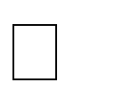User and Admin have different login activities for security. User can search doctor by area wise and category wise.

Blood bank uses Google maps for searching blood bank near its location. The user can know the doctor’s information through the application.

Admin can configure the database and modify the data in it.

###### Limitations of the System

**Device Defects**

Overheating is the common issue with most of the Android phones.

Storage is an issue, with most phones having minimal internal storage. Consequently, storing large apps, videos and files becomes an issue.

Data safety is another problem and the fear of losing data forever always hovers over users. While there are several apps that help backup data, none are tightly knit into the OS.

**System Defects**

The System possesses a great case of defects in android market there are various possibilities in which the system has defects. These System defects cause the program to lag or show errors while proceeding in its workflow. Several aspects of System Defects are as follows:

Little Memory for Storage Data Connection

Battery Issues. Performance Problems. Software Issues.

###### Future Scope of the Project

There are also few features which can be integrated with this system to make it more flexible. Below list shows the future points to be consider

Configure your city (Use Custom settings checkbox) Add/Update/Delete any numbers any number of cities Add different style and background for attractive interface Billing of patients

Blood Bank Information Management

Specific Targets for different doctors and patients at different locations. Payment Gateway will be added in the upcoming versions.

There will be direct appointments for the patients directly from their respective doctors.

# REFERENCES

### Books:-

Professional Android 4 Application Development - RetoMerier Expert Android Studio - Murat Yener , OnurDundar

 Beginning Android Application Development - Wei-MengLee The complete Reference Java 7th Edition - Herbert Schilt Introducing Java 8 ‘O Really’ - Raoul Gabriel Urma

### Website:-

[https://www.youtube.com](https://www.youtube.com/) https://[www.google.com](http://www.google.com/)

<https://www.javatpoint.com/android-tutorial> <https://developer.android.com/guide>



<http://mybscit.com/advance-java/program-to-authenticate-the-user> https://[www.slideshare.net/luckymoni76/c111230](http://www.slideshare.net/luckymoni76/c111230) https://drive.google.com/file/d/11SEMwASqF5IUqHpfdfknmwQlX7r_FJH7/vie w <http://1000projects.org/online-doctor-appointment-system-java-project.html> https://[www.softwaretestingclass.com/types-of-mobile-app-testing-tutorial-4](http://www.softwaretestingclass.com/types-of-mobile-app-testing-tutorial-4)

#### Glossary:-

**APK-** Android Package kit



**API-** Application Programme Interface **UML-** Unified Modelling Language **URL-** Uniform Resource Locator

**NDK-** Native Development Kit **SDK-** Software Development Kit **AVD-** Android Virtual Device

#### Appendices:-

**API** – Set of functions and procedure allowing the creation of application that access the feature of data of an other services.

**APK**- APK is the package file format file used by the android operating system for distribution and installation of mobile apps and middle ware.

**URL**- It’s the address on the internet where the data is available to the user.

**SDK**- The android SDK is a set of development tools used to develop application for android platform.

**AVD-** An AVD is a device configuration that is run with the Android emulator or real device capabilities.

**NDK-** The android NDK is a set of tools that allow you to use C and C++ code with Android.